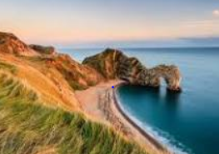
Optional task:
Friday 24th April

Task: Geography
Choose anywhere in the world. It can be somewhere you’ve been; somewhere you want to go or somewhere you are interested in. Example places could be the Jurassic coast in the South West of England, New Zealand, Hawaii, Iceland or the Botanical Gardens in Sydney. It’s completely up to you. Find out a minimum of 5 fascinating facts about the place or create a poster. Where will you make me want to go? Make sure you tell me where it is in the world.
Canada:
There are approximately 1000 towns in the whole of Canada.
The population of Canada in 2015 was around 37.7 million.
The emblem of Canada is a maple leaf because it represents unity and independence.
The emblem of Canada is a maple leaf because it represents unity and independence.
The famous curved part of Niagra falls is located in and owned by Canada.
The capitol city of Canada is Ottawa and it quite close to the border with USA.
Canada is located north of USA and west of Greenland making it one of the northmost countries in the world.

