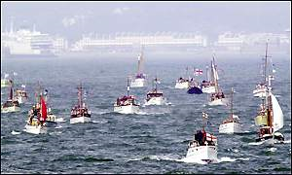
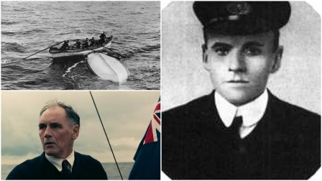
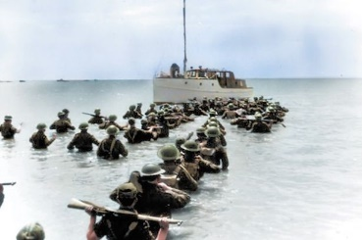

My Dunkirk Diary
Write your recount in role as a soldier waiting to leave Dunkirk or a sailor aboard a little ship attempting a rescue

It was terrible. One early Sunday morning, as a I read the weekly paper, I found at that Germany, and Britain were at war. Instantly, I knew what I had to do. I packed my bags and changed into my sailor’s suit; I then headed off to the harbour where my ship was. Waving goodbye to my family, I clambered cautiously onto the boat. My wife- Bethany Bims- had tears in her eyes, whilst cradling our new-born baby-girl, Elizabeth Bims. My dear son, Charles Bims, tried to persuade me to let him join me, however I said that he was too young, and it was too dangerous! Hugging me tight, I dwelled on whether I should forget all this and stay home; however I couldn’t- my country needed me! I set sail for Dunkirk, my dear friend George Graham, who was also heading off to war! I wasn’t going to fight, though I was going to sail. My ship wasn’t as big as thee other ships that were there, but it was a great help; my ship could fit approximately 50 people in it (including me and George). As I arrived, it was a horrible sight to see; war had only been declared 12 hours ago, however hundreds of wounded soldiers, were sprawled out on the dozens of other battleships that were already there. After 9 exhausting days of sailing dead, wounded, and hurt soldiers back to England, war was finally over!

