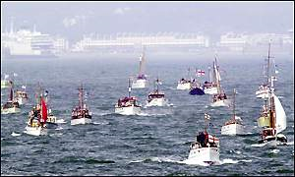
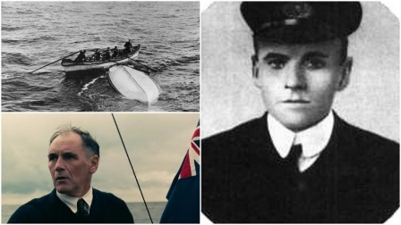
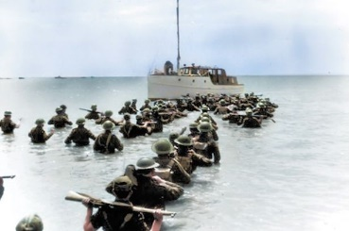

My Dunkirk Diary
Write your recount in role as a soldier waiting to leave Dunkirk or a sailor aboard a little ship attempting a rescue

Diary of Roger Lightoller (son of Captain Lightoller, owner of Little Ship ‘Sundowner’).

31st May 1940
I woke up with a start from a terrible dream, I glanced at the clock and it was still early. I tried to go back to sleep but could hear movement around the house. I laid there for a while wondering what he was doing. I could hear father open the medicine cabinet in the bathroom next to my bedroom, I was worried that he may be unwell, so I went to see him.
“Are you okay father? Are you unwell? I asked
“Did you not her the phone ring Roger? Our mission has been set; we need to get our boys home from Dunkirk”
I was still a little tired and it took a while for me to understand what father meant. He asked if I was coming, and if I was, I need to get ready fast. I was unsure if I wanted to go, it would be very dangerous, but I wanted to make father proud.
We loaded the Sundowner with first aid kits, blankets, food and water. We set sail from Ramsgate harbour heading towards Dunkirk, off to war we went.
The sea was calm, and the weather was clear, we were able to see France from a distance. We could hear shouting of the soldier's as we approached Dunkirk, their voices sounded frightened and panicky.
As we tried to moor the boat to the pliers but they were too high, we weren't going to rescue anyone this way, we needed another plan, to keep us safe father took us out to sea again so we can work out another plan.
A huge thundering, hovering noise came from above, it could only mean one thing – fighter planes. Father told me to take cover as it was an enemy plane, it was a Messerschmitt. I froze with fear, this could be it, we could die, I began to wish I had never come. Whilst I covered my head with my hands, I heard a second plane, father said it was a British plane, one of ours, a Spitfire. It fired and hit the Messerschmitt and the enemy plane crashed into the sea.

So far, we hadn't rescued anybody, we were failing! Father saw a huge war ship sailing back to England. Soldiers were hanging on to the side of the ship trying to get home. The war ship was making huge waves as it sailed, they wouldn’t be able to hang on for long. Father steered the Sundowner towards the war ship so that the soldiers could climb aboard and safely travel home.
After what felt like a long time we safely docked back at Ramsgate. What a day! I will never forget how proudly my father looked at me, that was my last thought before sleep.

