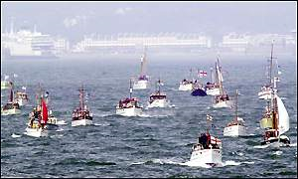
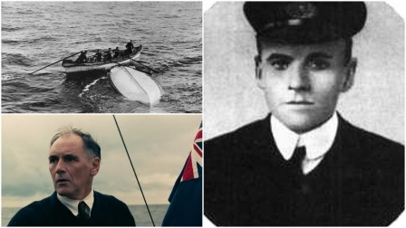
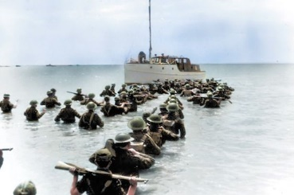

My Dunkirk Diary
Write your recount in role as a soldier waiting to leave Dunkirk or a sailor aboard a little ship attempting a rescue.
Recount of James Smith (1940)
Even though I'm a very old man now, I clearly remember the events of May 1940...
As I glanced at my watch, I heard the sergeant’s voice telling us to get down to the beach. The Germans were on us. Thundering planes soared above us and smoke began to engulf the streets, while we all ran across the road trying to avoid falling debris from planes and buildings near us. The sand was covered in ash as planes exploded above us. The beach was black with soldiers, thousands of them resting and waiting (exhausted) along the sand.
I had heard that Adolf Hitler was advancing towards the troops and we were trapped here now on Dunkirk beach. There was nowhere else to go. No hope. News came soon that the Belgian troops had already surrendered but it was only a matter of time before we would too. I sat down on a concrete brick beside me, pulling out a photo of my best friend w died by a German bomber a few days ago. As the dusk descended, the moon began to illuminate the beach, giving it a ghostly appearance. I was tossing and turning while my head rested on a solid, uncomfortable rock. It was a few hours later when I first noticed a spec on the Horizon. Straining my eyes to get a better look, I noticed a ship coming closer and closer to shore. Within minutes, there were hundreds of them, from small sail boats to large tankers and everything in between. A chatter of excitement rippled amongst the soldiers as they came even closer!
It was 4 days before I got off the beach. The first day, at least 7000 soldiers were rescued off the harbour, the second day 17,000, Surprisingly on the third day they managed to rescue 47,000 people off the beach. I was rescued on the fourth day along with 54,000 people mostly British and French troops. I managed to board a small fishing boat, with ten other troops including a soldier on a stretcher, whilst all the time listening to the sound of German and British planes in combat. It was remarkable to have been evacuated off the beach and finally set free over the sea. Like I said, I am an old man now but I can remember the events clearly.

