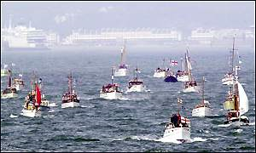
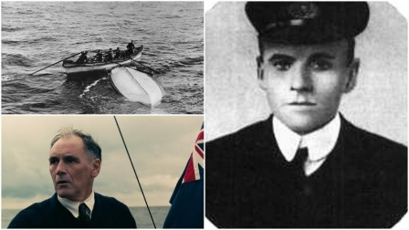
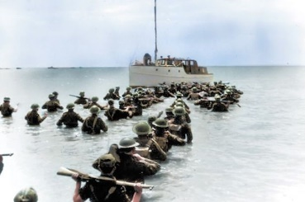

My Dunkirk Diary
Write your recount in role as a soldier waiting to leave Dunkirk or a sailor aboard a little ship attempting a rescue
It was only yesterday that the call went out - there weren’t enough destroyers, the army leaders asked for anyone with a ship to bring it to Dunkirk. I took on the job thinking it would be over quickly. It was a foolish thought. I was 16 and very hot headed always trying to show off. I charged in head first then five minutes away from shore I saw what awaited me. I saw death destruction and misery. But I said to myself no turning back this is for my country. I pulled some wounded army men out of the water and went to the drop off point. that’s when the German planes came along and bombed a ship not far to my right that got me in a hurry.

I worked days on end but German planes didn’t help as they passed over destroying hundreds of ships somehow I had survived it for now at least. But one day there was a sliver of hope there hadn’t been a German plane in sight. But for some reason that put all of us more on edge than when we saw them. It seemed eerily quiet then someone shouted one word that sent a shiver up my spine “torpedo” then came the explosion, it was on a medic ship that’s when we saw the full power of Germany. It destroyed the whole ship. From then on less and less people worked.

But I went on slowly and steadily less soldiers where found then there where none our government told us we saved 400,000 people but after what I saw I was changed forever.

