Homework at Upton

Reading
- Minimum 3x a week. Reading record must be signed by an adult.
- Can be completed on your own or with your parents.

Cross Curricular homework task

- Once a week – set on Friday, handed in on Wednesday.
- Task will be uploaded onto the class blog on the Upton Website every week.
- Task to be completed in this book and can be completed in any way you like – be creative!

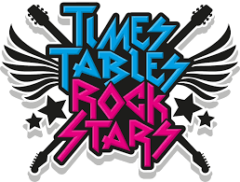
Times Tables Rock Stars
- Minimum 3x a week.
- Can be completed on tablets, laptops or mobile phones though the app or the website.

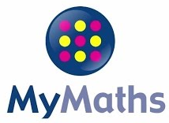
My Maths
- Once a week – Friday to Friday.
- Tasks will be completed online, with new tasks set every week.
- Tasks will always follow the subjects being taught in class that week.


Spelling Shed
- Once a week – Friday to Friday.
- Tasks will be completed online, with new tasks set every week.
- Tasks will always follow the spellings being taught in class that week.

Username: ________________  Password: ________________ | Username: ________________  Password: ________________ |   Username: ________________  Password: ________________

