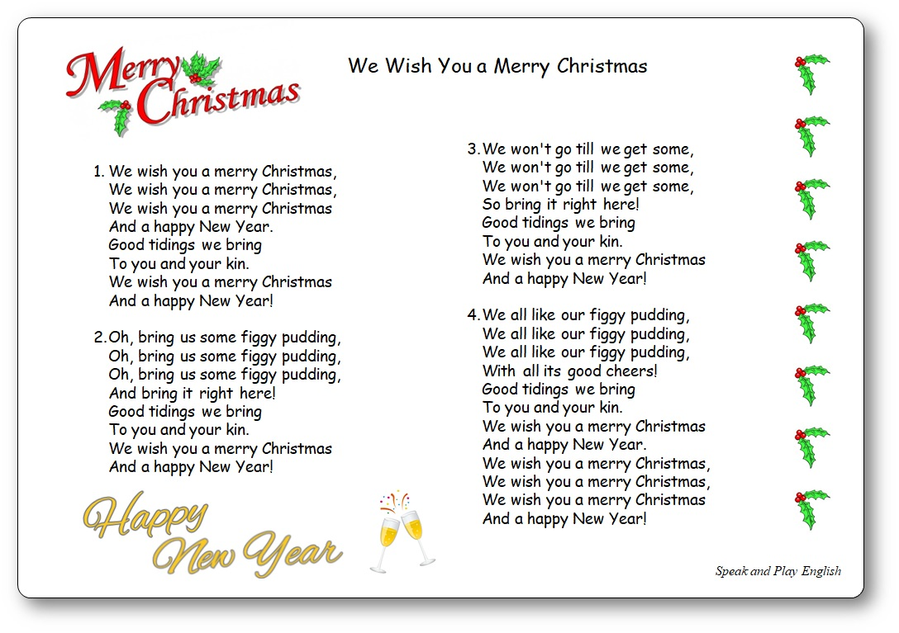
4) So…… Joseph took Mary to be his wifey, wifey, x2
Said he’d love her (clap) all his lifey, lifey;
Took her as his wife.

5) Now…… watch and listen and give God the glory, glory, x2
Watch and listen (clap) to the Christmas story
All about the Lord.

AN ANGEL TOLD MARY

1) An angel told Mary “The Lord has chosen you” x2
And Mary said “I’ll (clap) do what you want me to,
Yes, I will serve the Lord.”

2) But Mary was marrying Joseph the carpenter. x2
And would Joseph still (clap) want to marry her?
She left it to the Lord.

3) So…… God said to Joseph “She’s gonna have my baby, baby.” x2
“Mary is a (clap) very special lady:
Take her as your wife.”

