Wednesday 16th December
IALT: write a letter highlighting light and shade (changing the mood).
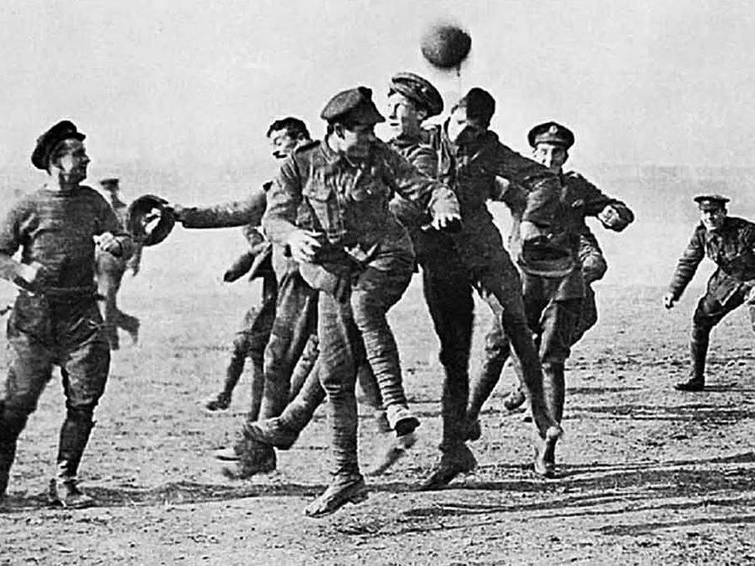

Christmas Day, 1914
Dear my beloved family,
I am letting you know how Christmas has been because unlike sitting in front of the fire and snuggling up on bed before we get our presents, I had to spend my Christmas sitting shivering in a boring old trench. We were so close to the Germans that we could sometimes hear them talking and chattering about what they were going to do next. But this Christmas I was sat watching out for gun shots bombs coming down and changing their attack order.

Suddenly it was time for my friend Mike to take the watch and I scurried back to my cot and snuggled up I must have dosed of because then Mike was shaking me “George wake, wake! Come look what the Germans are doing!” shouted MikeI scrambled to my feet grabbed my rifle and headed to the sand bags I could hear the faint sound of singing and when they were done, we applauded them. Yes, Britts were applauding Germans.

“What is it? What are those lights?" I exclaimed “they are lighting, the Germans collect all their lanterns and light them all up and then they chop down trees and place them in-between the sand bags do they don’t fall down and then they place the lights on the trees and they call them Christmas trees. After that we went to sing together but to many people were tied so the people that were wide awake sung with each other and I fell asleep to the sound of complete harmony.

The next day I awoke to the shear coldness of snow captivating me like a blanket and the chief waking everyone up saying “WAKE, wake up everyone there is a German solider on no man's land!” (that’s what we call the part of land in between the trenches).

everyone was so shocked that they grabbed their riffles and ran to the sand bags “hold fire!”, shouted the chief everyone lowered their guns as the chief walked out onto the battle field and shook hands with the German chief and soon after that all the soldiers began to come out of there trenches and shook hands then we all went back to the trenches.

Then the chief uttered “we have agreed that there will be no fighting until tomorrow at midnight and at 11 o'clock tomorrow everyone will go back to the trenches and that we have the guns at the ready. Is everyone clear” we al said yes and went back out to no man’s land and played a game of football.

I know this sound like good ne that the war will end soon but honestly, we have no clue the Germans are so unpredictable as you can tell by the letter.

All the best of luck
Love and kisses
George

