Wednesday 16th -December
IALT: write a letter highlighting light and shade (changing the mood).
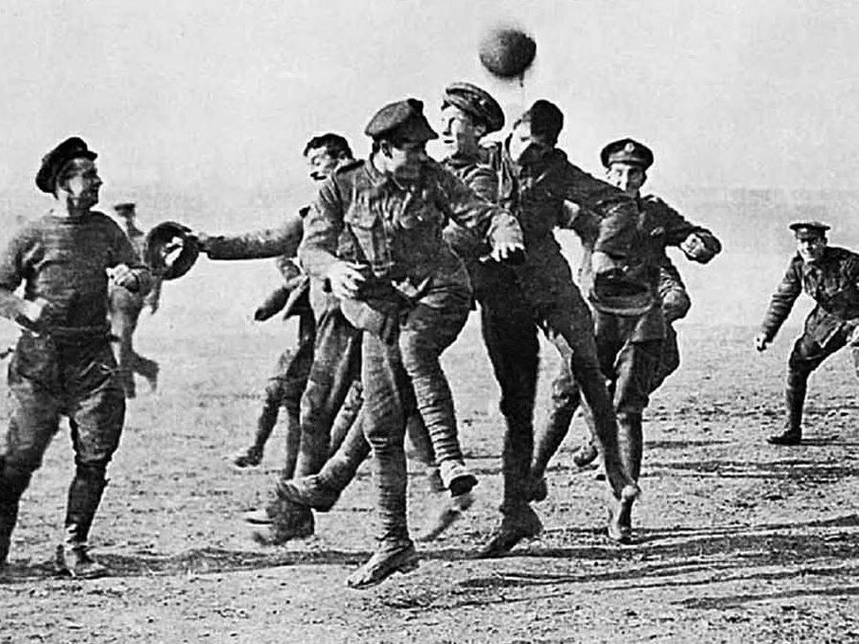

Christmas Day, 1914
Dear family
Its currently 4am in the morning, as you can guess most people are asleep but the rest are on night duty. You may be wondering why I'm writing at 4 in the morning. I couldn’t sleep as its Christmas today, although I won't be with you, I will be thinking about you the whole time.
I'll write about everything in the afternoon as I don’t know what we're doing as its normal war so there's not much to write about, you'll probably get this in about 2 days as I can't write until late at night.
I'm going to write this first bit as fast as I can as I have to go help my men.

Its 7:00 and I was opening my chocolate that you sent me when I heard the Germans singing, with you guys being German I understood very word and realized that they were signing silent night. Then I thought about something. Its Christmas I wanted a peace even if it was for one day I slowly emerged from my seat and heled my hat up to show no harm they all pointed guns at me but I heard one German say “don’t fire he's un armed” slowly I saw that one German man called otto also came out from the Germans' bunker. I called my men to come up with me so we could arrange peace with the other soldiers. Otto shouted to his men to get up and come is well without their guns and to bring nothing but themselves.

Otto approached me ( even though he could see I was nervous) he slowly reached his hand out and shake my hand I couldn’t believe it I was shaking hands with the other side I introduced myself and that’s when he said his name was otto. We all then played some football and ended up being friends we even trade gifts. Please don’t worry about me

You sincerely Jim

