Wednesday 16th December
IALT: write a letter highlighting light and shade (changing the mood).
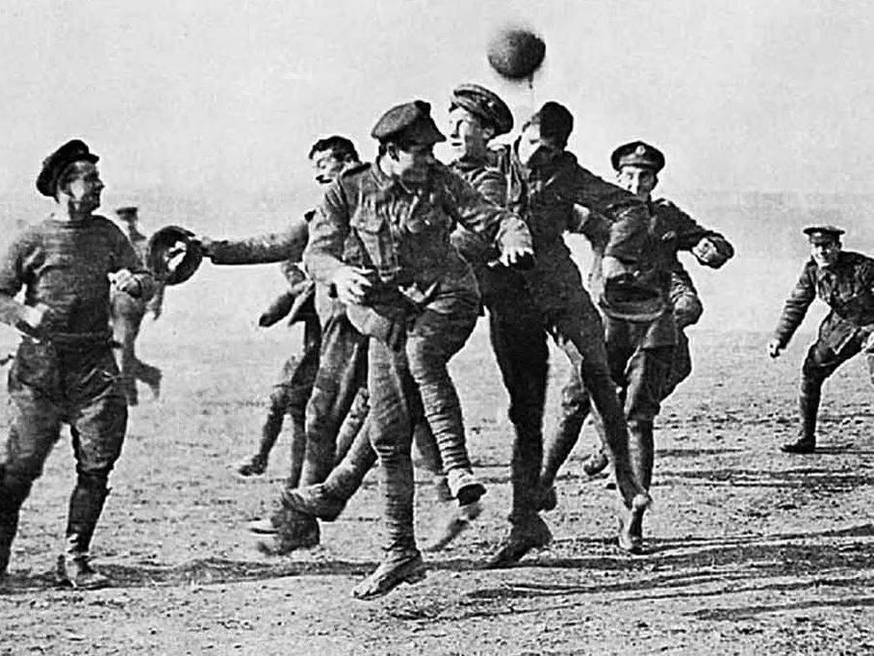

26th December 1914
Dear Mum and Dad,

I am writing to you on Boxing day because something extraordinary happened yesterday that I would never think would happen in a million years...

On Christmas day, the ritual music of bomb shells and shooting guns came to a sudden halt. We were camping down at the medical bay until we heard silence. Silence finally arrived until, there was music, Carols. Beautiful carols were sung in many different languages, 50 yards away. Silent Night, Feliz Navidad and White Christmas. John joined in with the German’s singing and later on, all of us were swaying side to side enjoying the scenery, making this moment last.

All of a sudden, we rose our guns. A man shaking with fear was ambling towards us with his hands high in the air. Our captain limped over to the side of their trench and spoke to the man. Our captain called out “Come to no mans land, we will shake hands till Midnight!”

We shook hands, played football and showed each other our loved ones. It turned midnight way too quickly but Louis didn’t hear us call and was shot dead! We sent a letter to his wife to tell her about her loss. What a tragedy.

Hope to see you soon,
Jack xx

