Wednesday 16th December
IALT: write a letter highlighting light and shade (changing the mood).
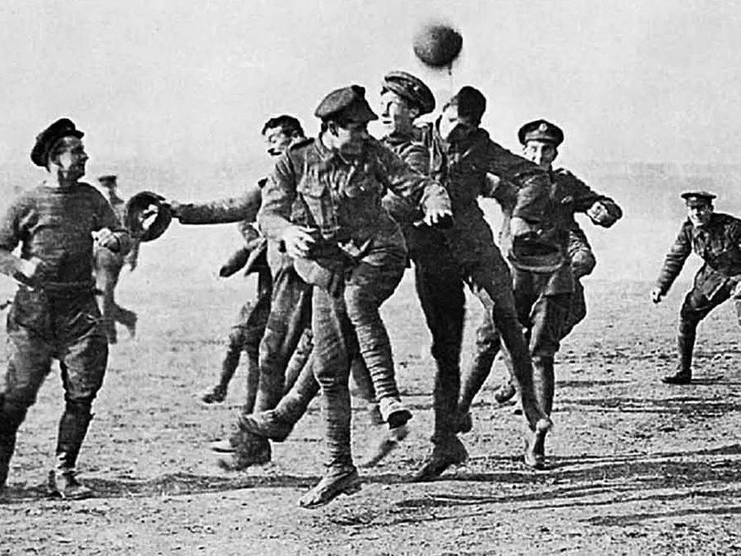

Christmas Day, 1914
Dear Bessie
Most of the men are asleep getting some rest however I'm here writing this letter to you as things have been strange and good this Christmas as there has been way less fighting and believe it or not, I sang silent night with my enemies in battle trust me it was weirder in person. Anyway, at first, we thought it was a trick to get us to come to them but then they came to us and we gave each other thigs like they gave us these things called a sausage which when I come home, I'll be sure to bring some!

We did still take precautions as we had ever got along with them the entire battle and so we were a bit confused but we decided to trust them and spend Christmas as a happy celebration and cherish all those we lost including dad I wish he experienced something nice in the war other than death and violence.

A couple minutes after we sung together, we heard faint chuckles in the distance and so we looked over the trench walls and we saw some Christmas trees all lit up with little names that had names of those who had passed and we all thought that we weren’t alike but if only we tried to get along with them, we could put our differences aside and find a new way to get along but those trees were certainly heart-warming.
.

On Christmas day, they came to us again and invited us to a game of football (it was a tie) and I learnt so much from them but then on boxing day before the sweat of the young men dried, we were back fighting for the lives of us and many more and it seemed like the fun was over.

Your loving brother

