Wednesday 16th December
IALT: write a letter highlighting light and shade (changing the mood).
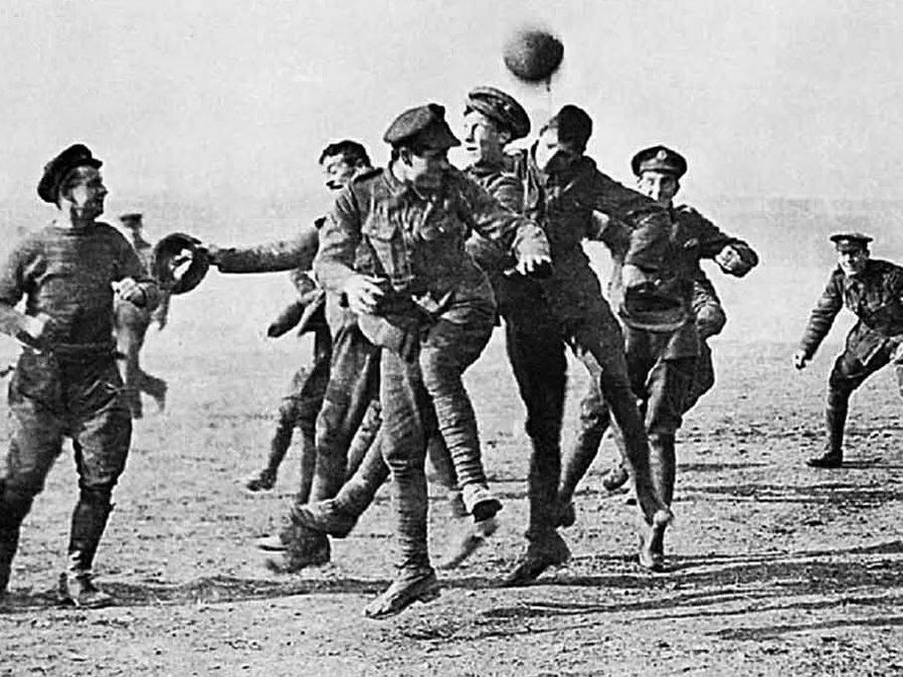

Christmas Day, 1914
Dear Mother
When I am writing this it is 2:00 in the morning most of the men are asleep but I am on duty tonight. I am writing to tell you what happened on Christmas eve To be honest what happened the other night didn’t feel real it felt like I was having a dream or it was a fairy tale. While you and the family are singing carols and laughing and joking what happened the other night was unreal. I don’t know if your ready but I and all my friends done the same here I did the same with the enemy soldiers on the battlefields of France

As you know I have recently been writing to you a lot more and I have been telling you have things have got a little more serious in fighting and shooting many people have died lately so we have all just been in our trenches waiting it has been a little cold lately as we are now in winter but it has not yet snowed.

The rain has been falling every day for a week now mud consistently getting stuck in my boots and my hands days has passed by now getting closer to Christmas I thought I would be able to come home and see everyone but I am not so sure anymore the days feel a lot longer than they use to be hours begin to feel like days begin to feel like months

As well as this, we could not stop feeling curious about what the German soldiers where doing on the on the other side of no mans land we began to wonder if this was the end of the war and we could all go home to see our loved ones.

As you know just a few days ago was Christmas day and Christmas eve we had our first freeze we were all huddling each other and trying to keep everyone warm but we all know we had to have guns in hands as you never know what is going to happen next. What happened next blew my mind we were close enough we sometimes heard the German solders voices.

For most of us the days felt the same little did we know what was going to happen next

Of course we hated them when they killed my friends but sometimes we felt like we had something in common. what they done next Surprised everyone in all different ways most weren't sure if we should trust them

I went to go lay down as I was on duty that night I must have fallen asleep I had a couple hours maybe longer my friend gave me a little nudge to wake me up I pounced as fast as I could to see what was the matter at this point I thought Steve ( my best friend) was shot.

I suddenly heard someone shout“ Christmas trees” I leaped from the floor to see if it was true

And so it was no one really know what do we all just froze in shock
Then we heard a faint noise of singing of course it was in German so no one really knew what they were saying but it sounded calm and relaxing they started coming closer and closer they dropped their guns no one really believed what was happening we all just froze and stood there is silence of course we had to have our guns at ready to make sure they didn’t have any secret plans to make shoot or let of bombs.

When the song finished the British including me applauded
Then they shouted ”you don’t shoot us we don’t shoot you”

As one man lifted his rifle and so did the others the caption shouted “hold fire” everyone was shocked but not me because I knew for this day and this day only we could enjoy Christmas day and not have to worry about what was going to happen next.

Me and all the boys played football with the others while were where doing this music played in the background we were all laughing and giggling with the other solders this went on for hours exchanging gifts and best of all I ate some German chocolate, but we all knew this couldn’t go on forever as much as we wanted it to.

The day quickly passed and before we knew it was back to war and fighting again. I need to get back to duty so I hope you and the family are well.

From your son steve

