Wednesday 16th December
IALT: write a letter highlighting light and shade (changing the mood).
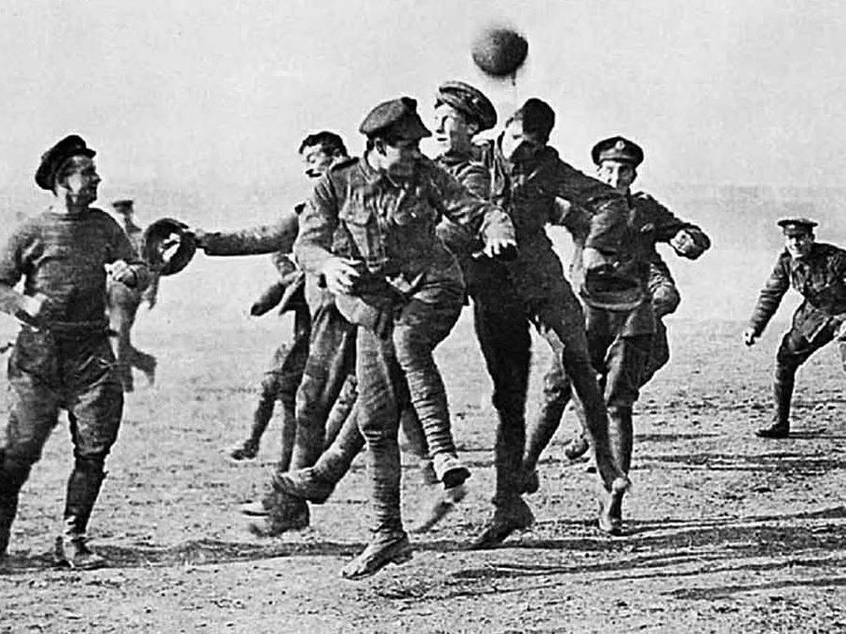

Christmas Day, 1914
Dear Mother
I am now wearing a Brodie helmet in a trench covered head to toe with mud, my comrade has been shot down to the ground by a sniper. In front of us is the no man's land, whenever someone step foot on it, they would be shot by a German sniper. It’s Christmas day and I haven't returned yet all of you would celebrating, while I have to defend our country.

We try to be extra careful not getting shot or get killed, but it was pretty hard. A few hours passed then someone gave us a package, I assume it was from our family. When I unwrapped, it I found a picture of you and a bar of chocolate. I was really happy that I found a picture of you.

The sky started to turn dark and I could the Germans singing a Christmas Carol, I didn’t know what they were saying because they weren’t speaking English. So, we joined in too. I thought maybe instead of being enemies we could be friends!

When it turned the next day, I can see the Germans have their gun at the ready, I thought to myself that I should go up there and make peace with them which I stupidly did, I know that I am going to die. I heard the Germans shouting and they were ready to shoot me then I put my hands in the air, then there was a man climbing up the ladder. We started slowly, walking towards each other and our comrades did as well. We shook hands and said our names, his name was Otto.

I showed him a picture of you he smiled, he didn’t have a picture of his family. One of my comrades told me to join a football match so I agreed. We played for a while until we heard something... a bomb. We quickly scrambled back to our trenches after I gave Otto’s coat back and said Merry Christmas. He had no idea I gave my chocolate but it is Christmas it might as well be a gift from me

Your beloved Son
Jim

