Wednesday 16th December
IALT: write a letter highlighting light and shade (changing the mood).
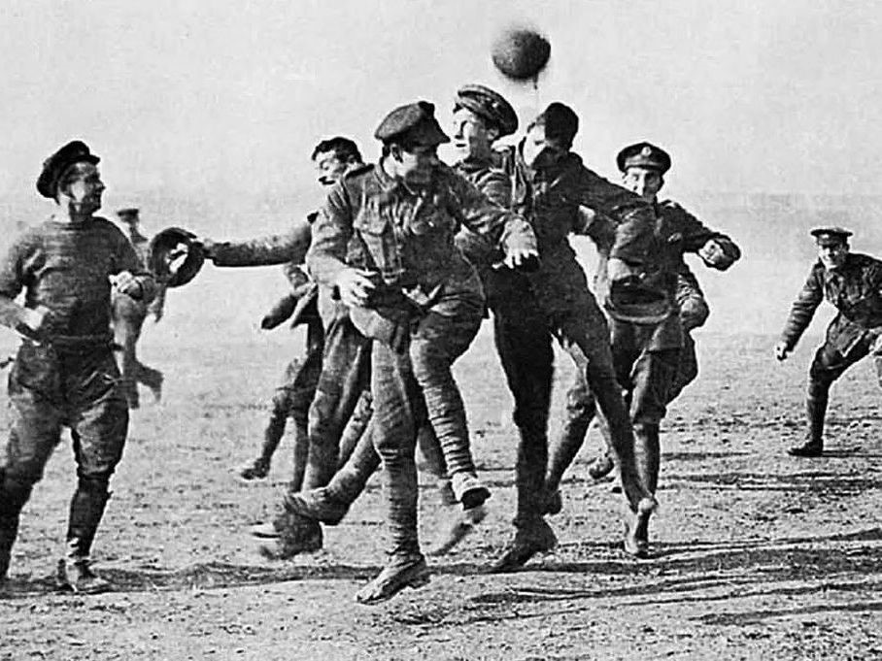

Christmas Day, 1914

My beloved sister Evie,
You will never guess what happened here in France yesterday. It was a normal day in the trenches with rats scuttling around our numb feet and moaning barb wire above our shivering bodies -in truth it was almost like a fair tale because it isn’t what would normally occur in a hazardous war like this- the men where all in there dugouts either asleep or resting when all of a sudden I decided I wanted to settle this completely.

I cautiously stood up (my entire body shaking with nerves) and I clambered over the top of the sharp, destructive wires. Holding my arms in the air to prove I was unarmed, I strode towards no mans land and my men behind me screamed at me not to go any closer to the opposite side. Suddenly, the Germans stood up to, carefully striding towards me. A German named Otto and I met in the centre of no mans land both desperate for no harm, without warning Otto and I shook hands and introduced ourselves.

In the blink of an eye, the Germans and Brits were both singing and playing football together and some were even showing each other family photos -and of course I showed Otto a picture of you and I-. Although they had killed many of my friends and we were supposed to be fighting them, that was the most fun I had had in a very long time.After our hours and hours of peace on the battlefield the time had come to an end. We all approached our damp, rotten trenches once again and settled in for the night. It’s now 2:30 in the morning on Christmas Day and nobody is awake apart from me. I always think of you whenever I can’t sleep or I’m hurt because I remember your extraordinary laugh and I hope you think of me. Remember I’m coming home soon so don’t be sad Evie and when I do finally come home then I will hug you until you can’t breathe. I didn’t think I could make it this far without you or without being hurt but look at me now I’ve come co far and this horrible war is nearly over. The Germans aren’t as bad as they may seem and I hope they think that about us to.

I truly hope you have had the best time ever without me and it hasn’t been to rough for you I mean it’s Christmas Day so you better be happy or else. I really miss you Evie and I hope to see you soon
Merry Christmas
From Brandon x

