UBBC – Finding our Foundations
Tuesday 5th January 2021
In History IALT: identify what I already know about the world around us.
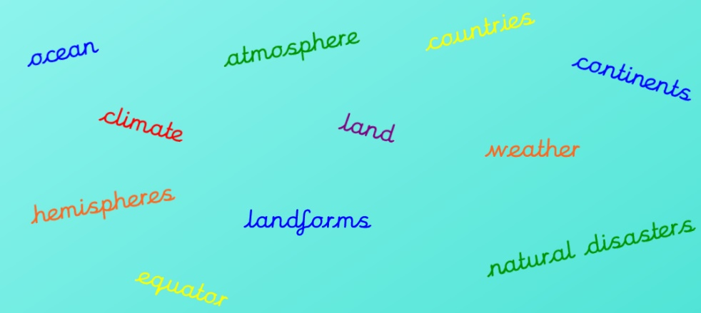


- Write a bullet point list using what you already know about the world around you. You can use the key words above to help jog your memory.
- . There are 7 continents
- . Most countries have their own language
- . Things like tsunamis and earthquakes are called natural disasters
- . One day is the moon making one ring around the earth
- . The moon doesn’t emit light it just bounces the sun’s light
- . There are 50 states in America

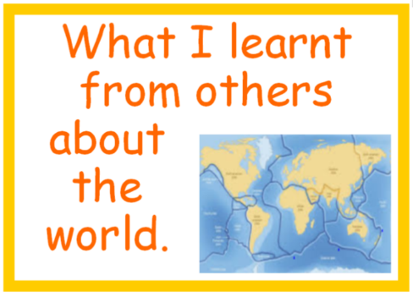

- Now write a bullet point list of what you learnt from others in the class about the world around us in the live lesson. Tip: if you cannot remember look back at the chat from the live lesson.
- . A few country flags are triangular
- . The place with the longest time difference is Las Vegas
- . There can be more than 1 main language in a country
- . There can be different biomes
- . Some places do not have water
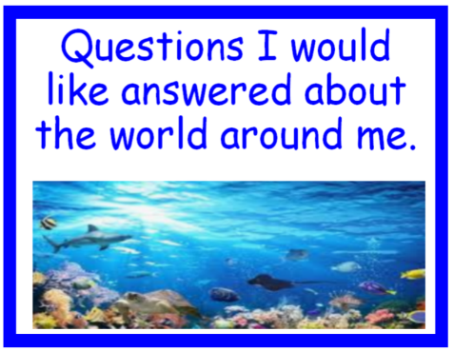
- What questions would you like answered about the world?
- . How long can an average fish live for?
- . How many galaxies are there?
- . What is the oldest animal that is not extinct?
- . Are there more animals like tardigrades?
- . If the world ended (minus tardigrades) what would be the last animal standing?



It would be a harmonious utopia where all nature is plentiful and every child would be suited with their own personal teacher who has been tailored for their needs. Every adult would take a personality quiz to see what their perfect job would be and if they don’t have one, they can make their own job with equal pay.

Design your perfect world!
For this part of the assignment, you can be as creative as you like!
You can draw your perfect world, create a model on the computer, or build a model. You will then need to take a photo of your world and upload it to your assignment (or email it to me). Good luck!

