UBBC
Thursday 7th January 2021
In History IALT: develop an understanding of the history of global warming and the controversy surrounding it.

- What does graph A show?
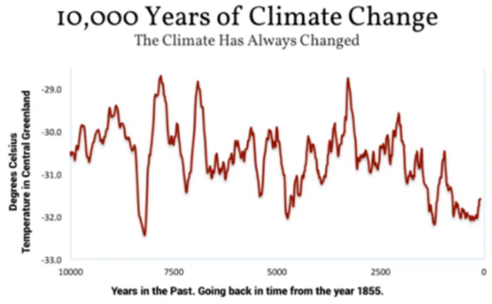
The graph shows 10,000 years of different climate change from 1855 going back in time. The temperatures kept increasing and decreasing as they went. The weather has changed a lot over the years for example it says it was –32 one year and –29 another year. The average temperature is around –30 to –31.

- What does graph B show?
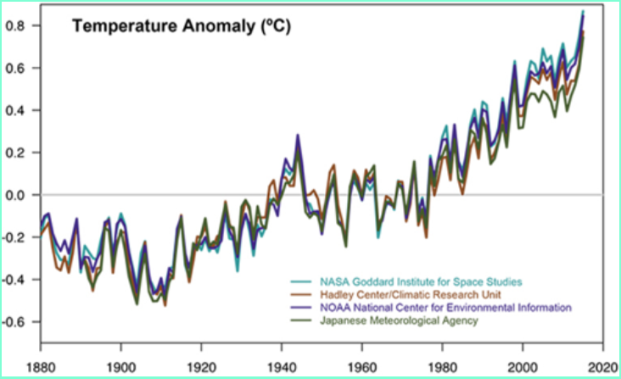
This graph shows the average temperature is steadily rising over the years. The years are pretty much the same but when it goes up the others go up as well. The Japanese Meteorological Agency is mainly rising at the end but not so much the beginning. The rest of the Companies or agencies or similar.

- What have you learnt from looking at the two different graphs?
That the temperatures are always increasing and decreasing over the years and that causes different side effects towards different things. Both graphs are from different periods of time – A is much larger period of time and B is a much shorter period of time. We need to be careful where we get our sources of information from. I think Graph B is a reliable source as 4 different researching companies found the same results.

- Read the research pages in the separate word document. Then complete the table, the first one has been done for you.

What has the government done to help global warming? | How successful has this been?
E.g. The government have been pushing for electric cars to be produced so less petrol is used. | This has not been very successful so far as transport fume emissions have been rising in recent years.
Reduced greenhouse gas emissions. | It has been quite successful as UK’s greenhouse emissions were at 42% below in 1990 in 2016.
Energy saving | Not very successful as the energy efficiency has been stalled since 2012
Transport pollution | Not very successful overall progress is far too slow and transport emissions have been rising in recent years. Also, there is now diesel pollution.
Keeping fossil fuels in the ground | No one should be drilling for new coal, oil and gas.

