UBBC
Thursday 7th January 2021
In History IALT: develop an understanding of the history of global warming and the controversy surrounding it.

- What does graph A show?
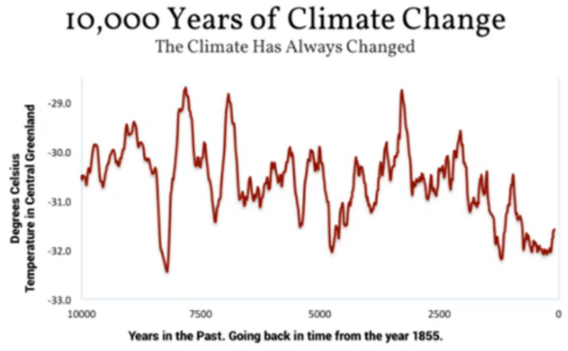
This graph clearly shows that over the course of many years climate change has not been the same over time it is constantly ascending and descending. There is no pattern to show where it may read since it is constantly moving all of the time. Some years it has been very high and some years have been very low.

- What does graph B show?
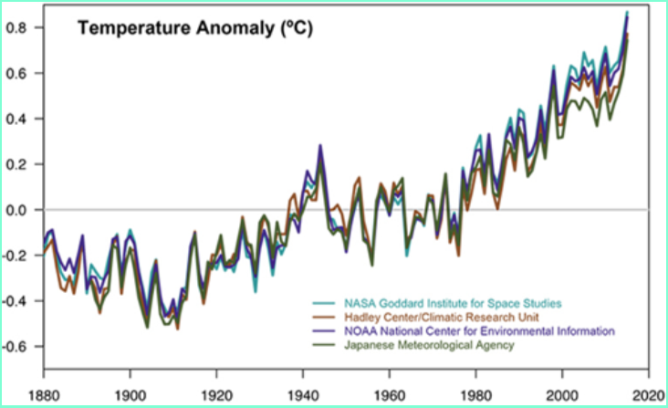
This graph clearly shows that climate change is going up at a deadly rate and this graph is clearly accurate because 4 big companies with experienced scientists have all recorded the same data so it must be accurate and this spike has to be lowered to help the future generations.

- What have you learnt from looking at the two different graphs?
I have learnt that according to the graphs climate change is rising at a worrying rate and something has to be done now or it will put people in the near future at severe danger. The graph showed us that it was never the same it was always moving. Both graphs are different lengths of time.

- Read the research pages in the separate word document. Then complete the table, the first one has been done for you.

What has the government done to help global warming? | How successful has this been?
E.g. The government have been pushing for electric cars to be produced so less petrol is used. | This has not been very successful so far as transport fume emissions have been rising in recent years.
The UK government has made a law to reduce its emissions by at least 80% by 2050. | So far greenhouse emissions were 42% below 1990 levels in 2016.
At least 75% of electricity needs to come from renewable sources which were supported by the government they also made coal power pay for its pollution costs. | In 2016 renewables grew from 7% in 2010 to 25%which was a success. However, the government’s policy attacks on renewables has driven away some investment. Also, they have focused on expensive nuclear power instead.
Energy saving policies to improve the efficiency of buildings. | This has been unsuccessful as the UK has the worst quality housing in Europe. People cannot afford to keep their housing warm which causes early death.
Supporting a new fossil fuel industry like fracking for shale gas. | No one should be drilling for new coal oil or gas if we want to avoid dangerous levels of climate change.

