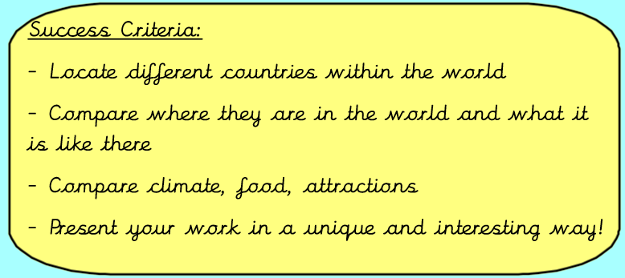
Tuesday 12th January 2021
IALT compare different countries in the world.
Task:
Create a piece of work comparing England, France and Brazil's similarities and differences
You must include the following:
- Where are the countries in the world? (Hemispheres, continents, oceans surrounding)
- What are the countries like - geographical features - rocky, flat etc
- What are the countries famous for? Landmarks, people, food etc
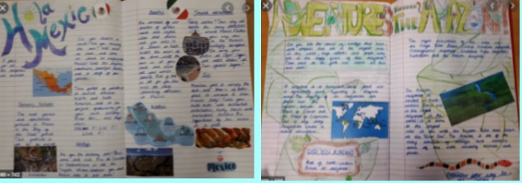
- What natural resources they have
- Climate
- What do they export/import?
- Threats - environment/weather
You can also include pictures, maps and did you know boxes.
You can present this however you want. You could do it below, on a piece of paper and send to me or you could do a PowerPoint and upload it with your assignment or email it over. You will need to use the internet (Google) and books at home to help you! We will blog some of them as well.

BRAZIL ENGLAND FRANCE
The country of Brazil covers roughly
half of South America, bordering the
Atlantic Ocean. Natural resources include:
bauxite, gold, iron ore, manganese, nickel,
phosphates, platinum, tin, clay, rare earth
elements, uranium, petroleum, hydropower
and timber. Some of the biggest agricultural
products are sugar cane, corn, soybean, oranges,
coffee, cotton, tobacco and cocoa. Brazil's annual coffee production of 2.6 million is the highest in the world and it is also the second largest producer of soybean and sugar. Brazil is rich in many of natural resources and is the world's leading producer of tin, iron ore and phosphate.

In England we have many different natural resources including:
- Coal
- petroleum
- natural gas - found in the British sector of the North Sea
- zinc
- tin
- limestone
- iron ore
- salt
- slate
- clay
- chalk
- gypsum
- lead
- silica
- arable land

France has an enormous number of natural resources including coal, iron ore, bauxite, zinc, uranium, antimony, arsenic, gypsum, timber, arable land, fish, gold deposits, petroleum, and clay. Currently, France’s annual gross domestic product has (US)$2.5 trillion, representing the third largest economy in Europe. Also, France is a member of the group of twenty richest economies in the world. However, since the 2008 financial crisis, France has experienced slow economic growth averaging 1% annually.

