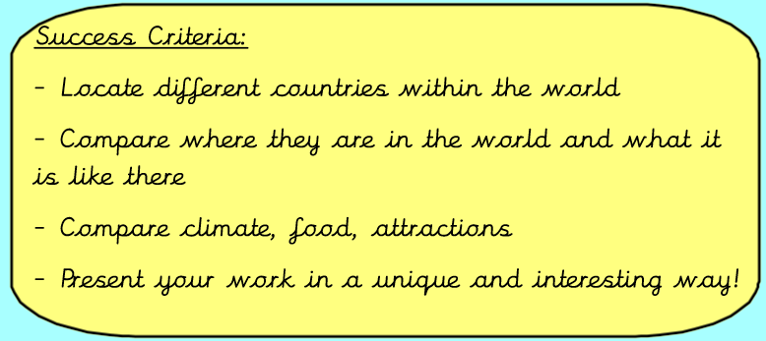
Tuesday 12th January 2021
IALT compare different countries in the world.
Task:
Create a piece of work comparing England, France and Brazil's similarities and differences
You must include the following:
- Where are the countries in the world? (Hemispheres, continents, oceans surrounding)
- What are the countries like - geographical features - rocky, flat etc
- What are the countries famous for? Landmarks, people, food etc
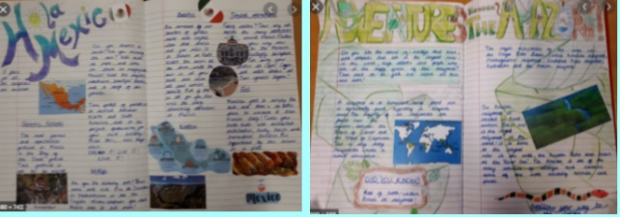
- What natural resources they have
- Climate
- What do they export/import?
- Threats - environment/weather
You can also include pictures, maps and did you know boxes.
You can present this however you want. You could do it below, on a piece of paper and send to me or you could do a PowerPoint and upload it with your assignment or email it over. You will need to use the internet (Google) and books at home to help you! We will blog some of them as well.

England

- England is a country that is part of the United Kingdom. It shares land borders with Wales to the west and Scotland to the north. The Irish Sea lies west of England and the Celtic Sea to the southwest. England is separated from continental Europe by the North Sea to the east and the English Channel to the south.
- One of the famous landmarks in England are Big Ben and the London eye they are both found in the capital of England: London.
- A food England is known for is fish and chips and a roast dinner.
- The population of England is approximately 68 million people.
This are England's major exports:
Did you know?
Did you know that England is measured at approximately 50,000 square kilometres?

France
- It is bordered by Belgium, Luxembourg and Germany to the northeast, Switzerland and Italy to the east, and Andorra and Spain to the south. The overseas territories tally French Guiana in South America and several islands in the Atlantic, Pacific and Indian oceans.
- A famous landmark in France is located in the capital of France which is Paris. The landmark is known as the Eiffel tower.
- France is known for fancy cookery but also simple things like: baguettes and croissants.
- The population of France is approximately 65 million people.
These are France’s major exports and imports:

Did you know?
Did you know that France is measured at approximately 674,000 square kilometres?

Brazil
- Brazil is a country in South America and it also shares borders with these ten countries: * Argentina * Bolivia * Colombia * French Guiana * Guyana * Paraguay * Peru * Suriname * Uruguay * Venezuela.
- The most famous landmark in Brazil is called the Iguazu Falls and another very famous landmark is named Christ the Redeemer. Christ the redeemer is in a place called Rio de Janeiro

- A famous food Brazil is known for is called Feijoada.
- The population of brazil is approximately 213 million people.
These are Brazil’s major exports:
Did you know?
Did you know that Brazil measures approximately 8 million square kilometres?

