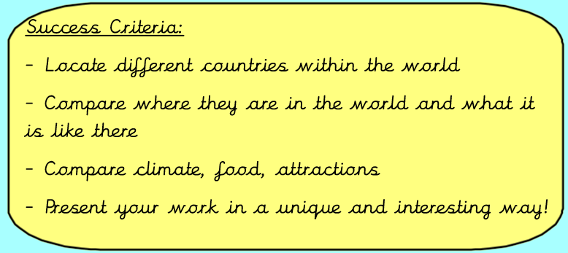
Tuesday 12th January 2021
IALT compare different countries in the world.
Task:
Create a piece of work comparing England, France and Brazil's similarities and differences
You must include the following:
- Where are the countries in the world? (Hemispheres, continents, oceans surrounding)
- What are the countries like - geographical features - rocky, flat etc
- What are the countries famous for? Landmarks, people, food etc
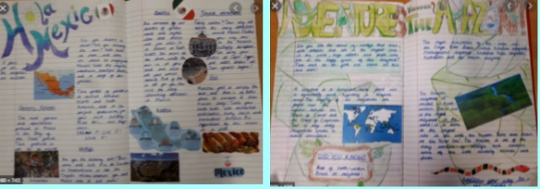
- What natural resources they have
- Climate
- What do they export/import?
- Threats - environment/weather
You can also include pictures, maps and did you know boxes.
You can present this however you want. You could do it below, on a piece of paper and send to me or you could do a PowerPoint and upload it with your assignment or email it over. You will need to use the internet (Google) and books at home to help you! We will
Compared by | England | France | Brazil
Surrounding sea | North Atlantic | North Atlantic | South Atlantic
continent | Europe | Europe | South America
Capital city | London | Paris | Brazillia
population | 53 million | 66 million | 207 million
Famous Food | Fish and chips | Escargot[snails] | Coxinha
climate | temperate | temperate | tropical
Natural resources | Coal natural gas | Coal and uranium | Tin and iron ore
Geographical features | Low-lying in the south mountainous in the north | Flat plains in the north and mountainous in the south | Islands in the north the low lands of the amazon and coastal ranges
Export and import | Imported cars exported precious metals | Exported machinery import consumer goods | Exported iron ore imported petroleum
Famous landmarks | Stone henge and Hadrian's wall | Eiffel Tower Arc de Triomphe | Christ the Redeemer statue

