
Country | Hemisphere | Continent | Oceans | Size | Population | Coastline | Highest point | Longest river | Terrain | Natural resources
England | Northern | Europe | North atlantic | 50,301 sqm | 55.98 Million | 1988m | Scafell pike 878m | Severn 220 miles | Low mountains, hills, forests, lowlands, urban | iron, zinc, potash, silica sand, fish, timber, wildlife, petroleum, natural gas, hydropower, wind power, lead, tin, copper, china clay, arable land, and coal
France | Northern | Europe | North atlantic | 210,126 sqm | 67.06 million | 2129 m | Mont blanc 4808m | Loire 629 miles | Mostly flat plains or gently rolling hills in the north and west, and mountains in the south | Coal, bauxite, zinc, uranium, antimony, arsenic, potash, feldspar, fluorspar, gypsum, timber, fish, gold
Brazil | Southern | South America | South atlantic | 3.2 M Sqm | 211 million | 4655m | Pico da neblina  2995 m | Amazon 4345 miles | Coastal mountain ranges vast central plateau. Remainder is sedimentary basins | bauxite, gold, iron ore, manganese, nickel, phosphates, platinum, tin, clay, rare earth elements, uranium, petroleum, hydropower and timber
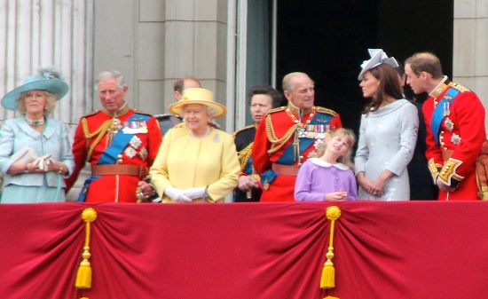
- England is famous for it’s Royal family and castles
- Know for afternoon tea and cake and roast dinners
- National symbol is the lion.
- The weather is mild in the summer and winter with evenly spread rain.
- Heathrow is the biggest airport in Europe.
- The shard is the tallest building in London.
- Environmental issues are dealing with waste and climate change.
- Biggest exports are mechanical machinery and cars.
ENGLAND

BRAZIL

- Famous building is The Christ The Redeemer.
- World’s fifth largest country.
- Language is Portuguese.
- National symbol is The Jaguar.
- They export coffee.
- Largest rainforest in the world.
- Their weather is tropical.
- Their drink is Guarana made with red berries
- Feijoada, a bean stew made with pork and rice
- The clearing of rainforests is an environmental threat.
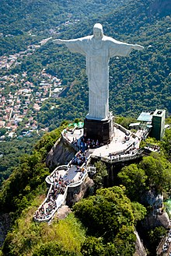
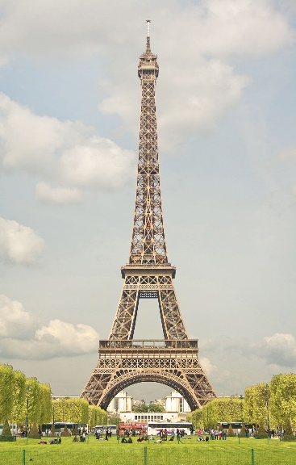 FRANCE
- Famous building is the Effiel Tower.
- National symbol is the Rooster.
- France is known for fashion and designers.
- Famous for fine arts.
- Foods are the baguette, cheese and pain au chocolat
- French is the second most studied language.
- The summers are warm and winters are cold.
- Environmental issues are climate change and pollution.

