Tuesday 19th January 2021
IALT: Compare human and physical geography.
1. Explain in detail what human and physical geography is?
Human geography is when humans create the resource, they are manmade. For example, a house. Physical geography is natural like trees and rocks.
2. Research, locate and describe some key human features of England. Some famous landmarks are listed below.
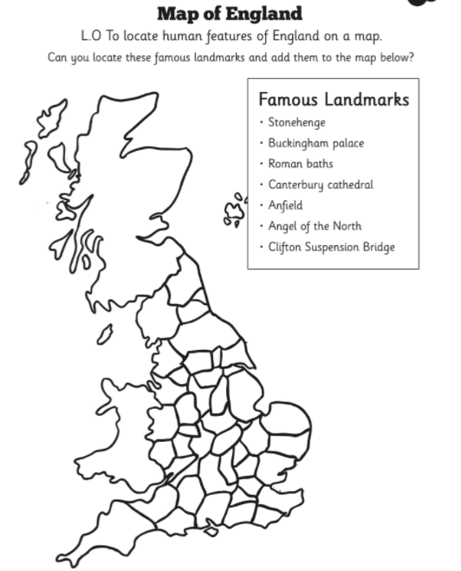

-Stonehenge: No one knows how Stonehenge was made. It is a monument with heavy stones in a circular pattern. Each year on the 21st June (the longest day of the year) the sun rises over the Heel Stone.
-Buckingham Palace: This palace is in London and has lots of visitors. It was bought by King George III in 1761 as a private residence for Queen Charlotte. There was a break in to Queen Elizabeth II’s bedroom in 1982!
-Canterbury Cathedral: I have visited the cathedral in Canterbury. It has beautiful stain glass windows and high ceilings. The miracle windows in the trinity chapel show some of the miracles that took place after the murder of Thomas Becket. It costs a lot of money to keep it nice.
3. Research, locate and describe key physical features of England.
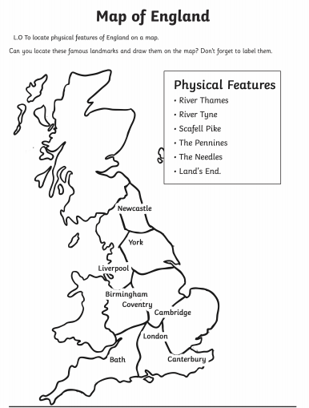

Some are listed below.
- River Thames: We drive under the river Thames in a tunnel when we visit family in Essex and we drive on a bridge over the Thames on our way back. The Thames is a river that runs through London. It is 215 miles long, the longest river in England.
- The needles: It is a row of 3 stacks of chalk that rise about 30 metres out of the sea. It is off the Isle of White in the English Channel. Did you know there is a little lighthouse at the end of the last needle?
- Land’s End: That is in Cornwall. It is the furthest point south of the UK. There is a famous walk you can do from Land’s End all the way up to John O’Groats in Scotland.

