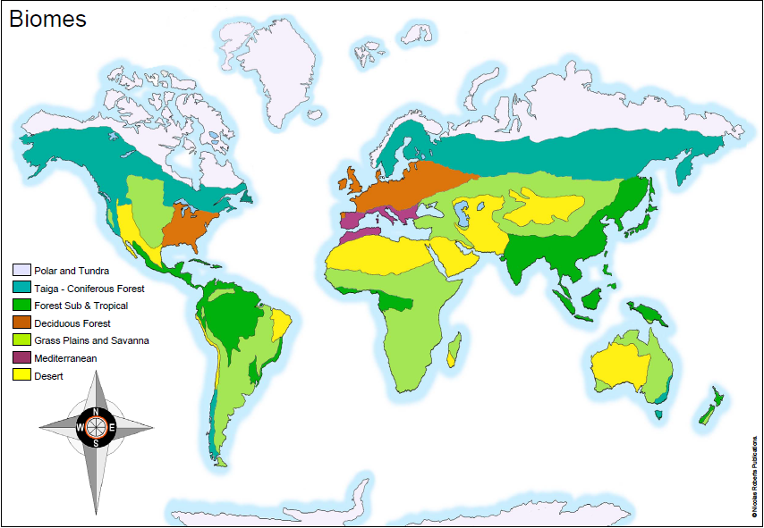
Wednesday 20th January 2021
IALT: locate and understand about biomes

Choose one of the major Biomes to research – you will need this research for tomorrow’s lesson. Be sure to include:
- Key locations
- Climate / weather
- Physical features (volcanoes, mountains, rivers, coasts)
- Plants
- Animals
- General facts
- Did you know boxes
- Images of your chosen Biome

CHALLENGE: What impact do you think human activity has had/is having upon the different biomes around the world?
The Tundra and Polar biome facts:
The key locations of the Tundra biome are Alaska, edges of Greenland, Northern Canada, Russia, Northern Siberia and Northern Scandinavia.This is an image of Northern Scandinavia.

- The climate in the tundra areas of the world are -18 degrees Fahrenheit or -8 degrees Celsius. Brrr that is cold. In the winter the average temperature is -30°. In the summer the average temperature is 37-54° F.Rainfall is 6-10 inches of rain a year

Mountains are one of the physical features in the Tundra. Here is one of the names of a mountain in the Tundra biome, Alphine Tundra. Here is an image of a river In the tundra biome.

Plants:
Here are some names of the plants that grow in the tundra biome. Caribou moss, Bearberry, Arctic Willow and Labrador tea. Here is an image of Labrador tea:

There is A range of animals in the Tundra biome some of which are snowy owls, polar bears, caribou, Arctic foxes and Arctic hare.
Did you know:  That these animals live in the harshest climates. | Did you know: | Did you know:

General facts about the Tundra biome:
- The tundra biome is one of the coldest places on the planet. It’s the coldest of all of the biomes and temperatures can easily reach -34°C.

- The animal populations of the tundra biome can change greatly over the course of a year. Some animals spend all year in the biome and choose to hibernate during the winter.

3. The tundra biome actually covers 1/5 of the total planet’s surface. Despite this large space, only 48 animals are known to call this region their home.

4. The tundra biome is actually called a “sink.” This is because the area is able to store massive amounts of carbon dioxide.

HERE ARE SOME IMAGES OF MY CHOSEN BIOME:

