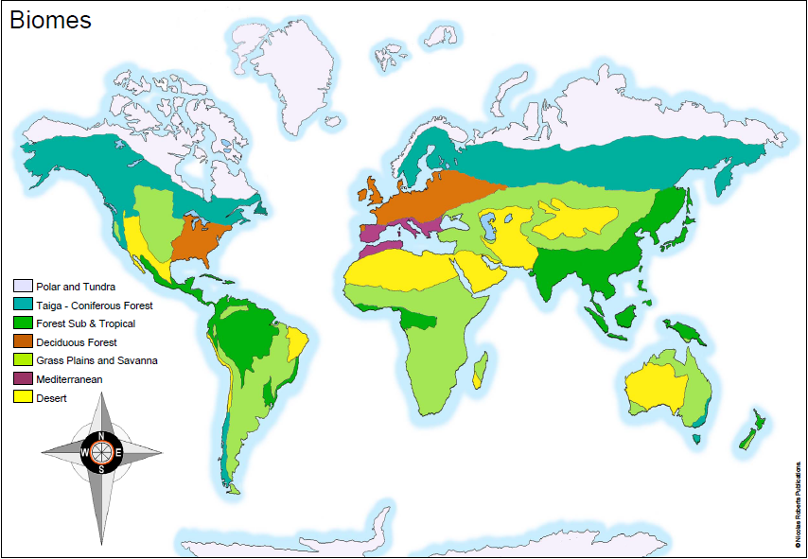
Wednesday 20th January 2021
IALT: locate and understand about bi

Choose one of the major Biomes to research – you will need this research for tomorrow’s lesson. Be sure to include:
- Key locations
- Climate / weather
- Physical features (volcanoes, mountains, rivers, coasts)
- Plants
- Animals
- General facts
- Did you know boxes
- Images of your chosen Biome

CHALLENGE: What impact do you think human activity has had/is
having upon the different biomes around the world?
Arctic Tundra
The Arctic Tundra is the coldest biome of them all and is the most uninhabited. With its extremely low temperature only the most smart survivors call this their home. From the fearless polar bears to the genal penguins. The ground is fully frozen and that is the reason why there are no trees, plants and no sort of vegetation and greenery anywhere it is just pure ice and snow.

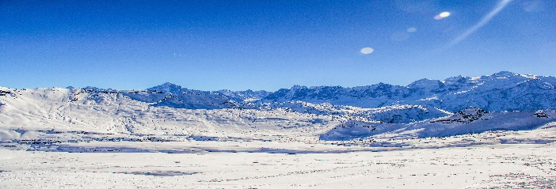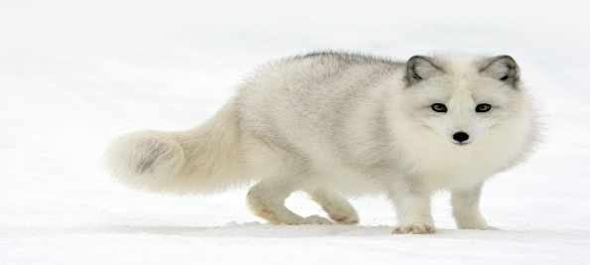
This Photo by Unknown Author is licensed under CC BY
The arctic is home to a range of animals and here are some examples of the inhabitants here.
Polar bears
Different species of Penguins
Arctic fox
Artic hare
Musk oxen
Reindeer
Grizzly bear
Walrus
Seals
All of these creatures have found their own way of adapting to the coldness of the arctic.
Within the Tundra there are parts of North America, Europe and Asia and its land mass covers a tenth of the Earth’s surface. Unbelievable here they get as little rain as a desert.
Even when it is mid summer here the sun is very low and the average temperature is still far below freezing. For half the year it is pure darkness all day and all night but in the other 6 months it is constant sunlight but it does not generate much warmth.
Much to lots of people surprise, fierce winds affect what animals and plants that you may be able to see
Underneath the Tundra is a thick layer of frozen soil called the permafrost so water can not seep into it.

Some animals here hibernate like the grizzly bear, or migrate south like the reindeer and many birds.
Plants are needed for lots of the animals but in these conditions how do plants grow? Plants grow very near to the ground because of the winds and only last long enough to produce seeds.

