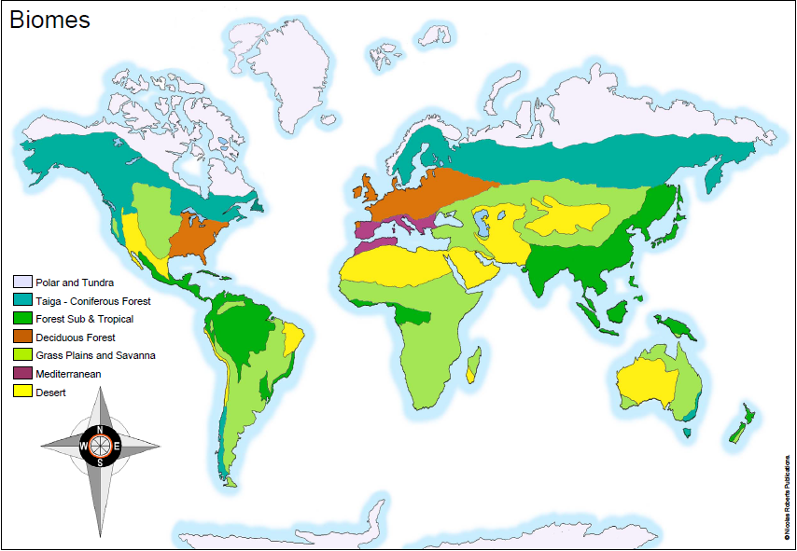
Wednesday 20th January 2021
IALT: locate and understand about biomes

Choose one of the major Biomes to research – you will need this research for tomorrow’s lesson. Be sure to include:
- Key locations
- Climate / weather
- Physical features (volcanoes, mountains, rivers, coasts)
- Plants
- Animals
- General facts
- Did you know boxes
- Images of your chosen Biome

CHALLENGE: What impact do you think human activity has had/is having upon the different biomes around the world?

Aquatic Biomes
The Aquatic biome includes the habitat around the world that are dominated by water- from tropical reefs to artic lakes. It is actually one the largest of all world's biomes. The aquatic biome is divided into freshwater and marine regions.
The climate of the aquatic biome is mostly varied. Since it is the largest biome in the world, the climate varies from –40 degrees Fahrenheit to over 100 degrees. The average temperature is 39 degrees Fahrenheit but it is warmer near the equator.
There are a lot of animals that live in the ocean such as: fish, eels, clownfish, sharks, shark fish, etc. But in more exotic places there's: crocodiles, tropical fish, sharks, wales, etc.
Did u know?
- The aquatic biome covers about 75% of the world which leaves 25% of earth
- I love this fact, only 5% of the ocean has been discovered!!!!!

