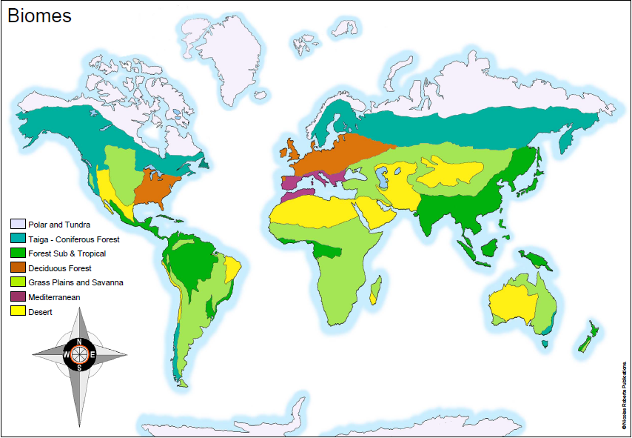
Wednesday 20th January 2021
IALT: locate and understand about biomes

Choose one of the major Biomes to research – you will need this research for tomorrow’s lesson. Be sure to include:
- Key locations
- Climate / weather
- Physical features (volcanoes, mountains, rivers, coasts)
- Plants
- Animals
- General facts
- Did you know boxes
- Images of your chosen Biome

TUNDRA BIOME

The Tundra biome is Painted with a thin layer of snow but also home to many animals such as, Polar bears, snowy owls, Arctic foxes, caribou, ermine. But it isn’t always snowy... The Arctic Taundra has short summers but long, dark winters. Tundra biomes are usually in the south or north pole but also in areas with high latitude.

CHALLENGE: What impact do you think human activity has had/is having upon the different biomes around the world?

