Man Made
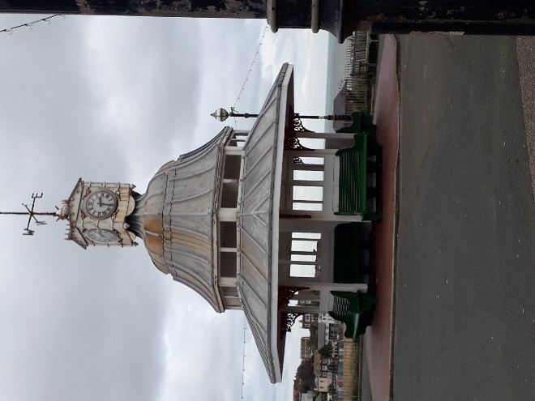Broadstairs Clocktower on the seafront was built to commemorate Queen Victoria’s Diamond Jubilee in 1897 Broadstairs Bandstand was opened in 1892 by Princess Louise, daughter of Queen Victoria.

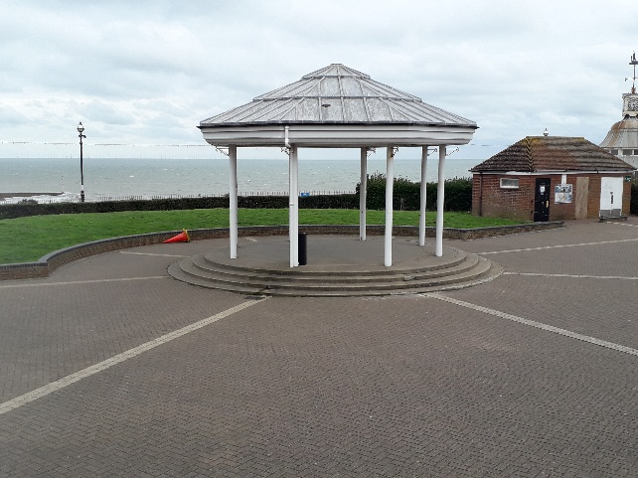Bandstand
The first bandstand was built in 1892 but then it was situated on the top of a large shelter in nearby Chandos Square. It was moved, in 1897, to a position slightly nearer the. cliff edge.
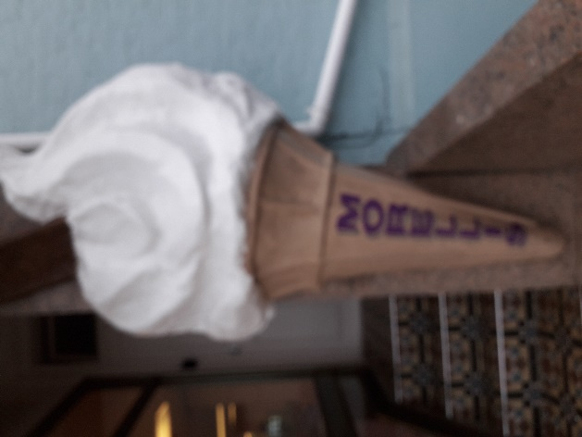morellis ice cream
Every morning since 1907, in a tradition continued to this day, the ice cream at Morelli's is made fresh in every store. It began in Scotland when Giuseppe and his young son Mario, recently arrived from Southern Italy, set off on their bicycles every morning to sell their ice cream – not returning home until every last scoop was sold out.
NATURAL
The sea forms part of viking bay
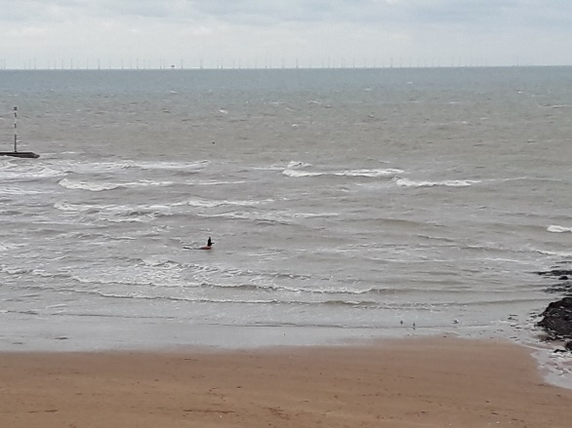

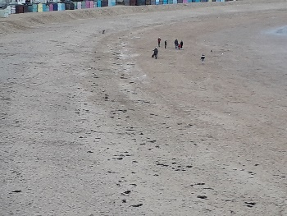 Viking Bay beach mad

Yuka plarnts



