Physical Human-made features
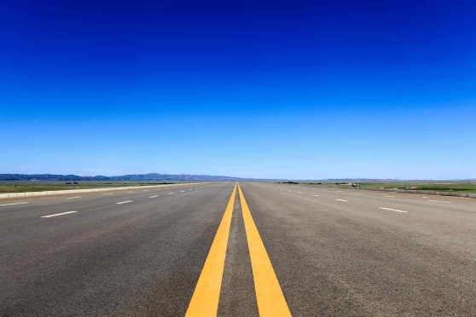
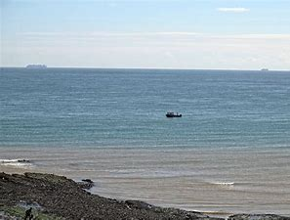
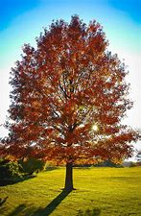
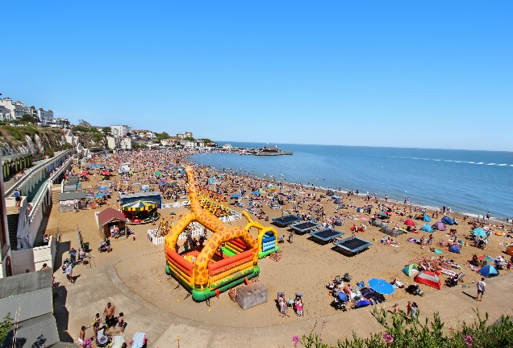

Features
Some trees are man-made, but some are not man made. Apple, pear and many more trees are human features because you plant them. Trees are beautiful. In the autumn, the leaves turn orange and yellow and red. In the winter there are no leaves on the tree.
The road is a human feature. The weather, like frost, snow and rain make potholes and cause other damage to the road surface. And then, the heavy trucks driven on the road really tear them up. I know that road crews have a hard time repairing the streets, and after reading this article I can see that it's quite a complicated process to make a road, but I guess I just wish things were a little better where I live!
The sea is a physical feature because only 5% of the sea had been discovered ever! The sea is extremely dangerous because it has killer sharks and many other horrible creatures in it. There is coral wreaths and other amazing sights.

Viking bay is half a physical and half human. so it must be a physical feature that was made over time. It is peaceful in the winter because its cold in the sea at winter. The rides, trampolines and bouncy castles are human features. The cliff is a physical feature because you would die if you built the cliff it could fall on you!
This is a human-made feature because it didn’t just pop out of nowhere because people make houses. most of the time it is peaceful except from when you have a baby in the house.

