Tuesday 26th January
IALT demonstrate understanding of the scientific meaning of adaptation.

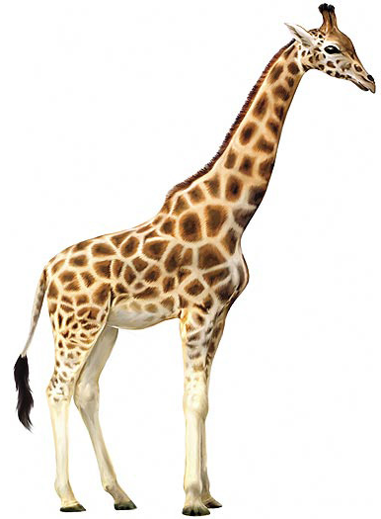 How do you think a giraffe has adapted to where it lives?

- It has a long neck to reach leaves in tall acacia trees
- It has a camouflaged coat with spots of different sixes to help it hide in the African savanna
- It has a long tough to help it get leaves off the trees
- It has a fringed tail to keep flies away.

Adaptions of a polar bear:
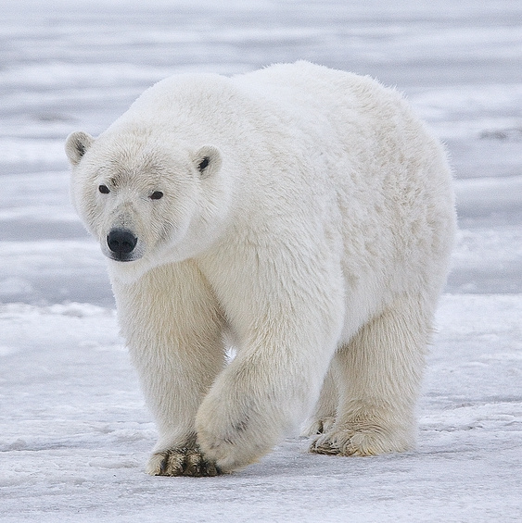

- They have large claws and teeth so that they can tear apart their prey.

- They are very good swimmers and divers, which helps them swim from one ice floe to the next one.

- Polar bears have a thick layer of fat which keeps them warm when swimming in the cold waters.

- They have white fur so that they can blend in with their environment.

- Polar bears have a great sense of smell so that they can catch their prey.

These are one of the many adaptions that the polar bear has I will now write a few sentences for each adaption.

Polar bears are such good swimmers because of the buoyancy they get out of their body fat and their large forepaws provide propulsion, allowing them to attain a speed of up to 10 km per hour.
In addition to a really dense layer of fat (approximately 2-4 inches!), polar bears also have two fur coats—one protective outer layer and one dense undercoat to help them survive in the Arctic’s harsh climate.
Polar bears coats are white so that they can blend in with their environment and sneak up on their prey easily.
The Polar Bear’s sense of smell is the best in the whole animal kingdom with the ability to smell their prey and other polar bears at very long distances. Their sense of smell is so good that most of the time it relies only on it.

Adaptions of a meerkat:

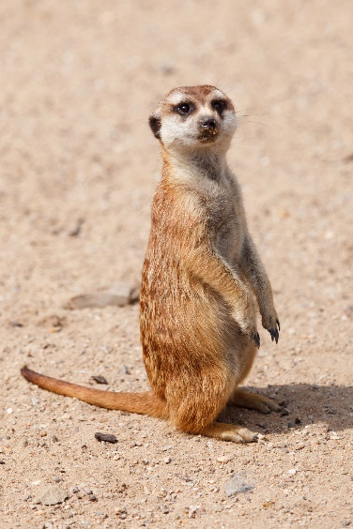

- Dark patches around their eyes help them be effective lookouts by reducing the glare of the sun.

- Their eyes have a clear protective membrane that shields them from dirt while they are digging. Their eyes also close tightly to keep the dirt out.

- Meerkats have dark-skinned bellies are covered with only a thin layer of fur, allowing the meerkats warm themselves by lying face up in the sun.

- Meerkats have a reasonably thin coat of fur, due to their habitat. As mentioned they live in the deserts of Africa.

- The meerkat lives in groups from 20-50 members due to the many roles they have.

These are some of the many adaptions that the meerkats have. Meerkats live in large groups so that they can protect one and another due to the many predators that hunt them.

Meerkats have formed a strong immune system that is strong enough to fight a scorpion sting that can paralyse a grown man or kill a small child.

