Tuesday 26th January
IALT demonstrate understanding of the scientific meaning of adaptation.

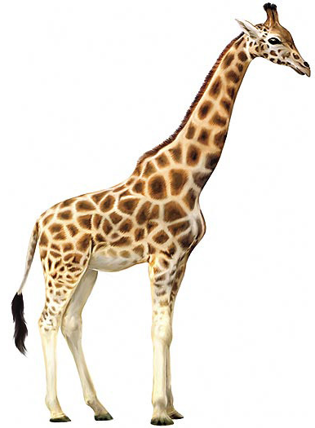 How do you think a giraffe has adapted to where it lives?

- It has a long neck to reach leaves in tall acacia trees
- It has a camouflaged coat with spots of different sixes to help it hide in the African savanna
- It has a long tough to help it get leaves off the trees
- It has a fringed tail to keep flies away.

HOW HAVE GIZMO AND PEPPER ADAPTED TO BEING IN MY HOUSE?
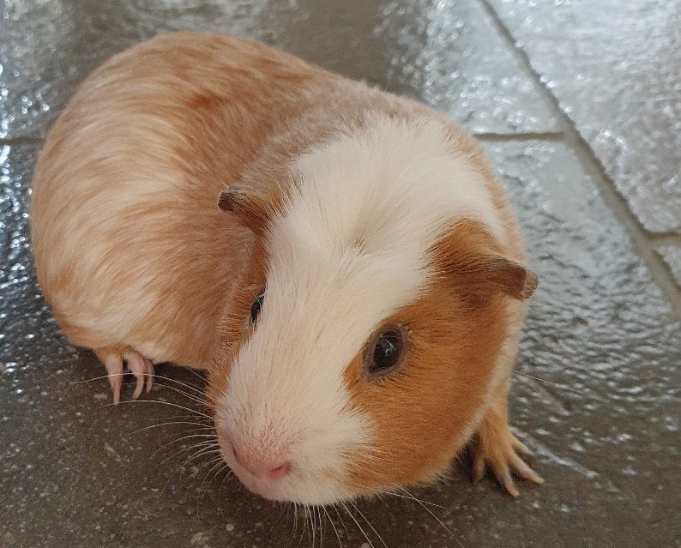GIZMO 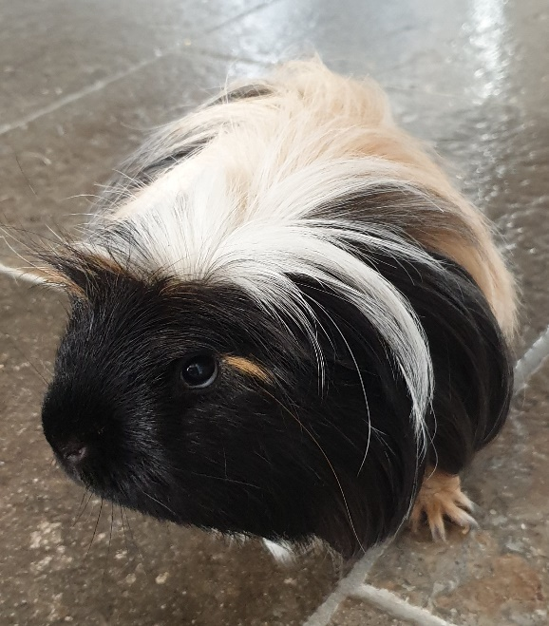PEPPER

My drawing

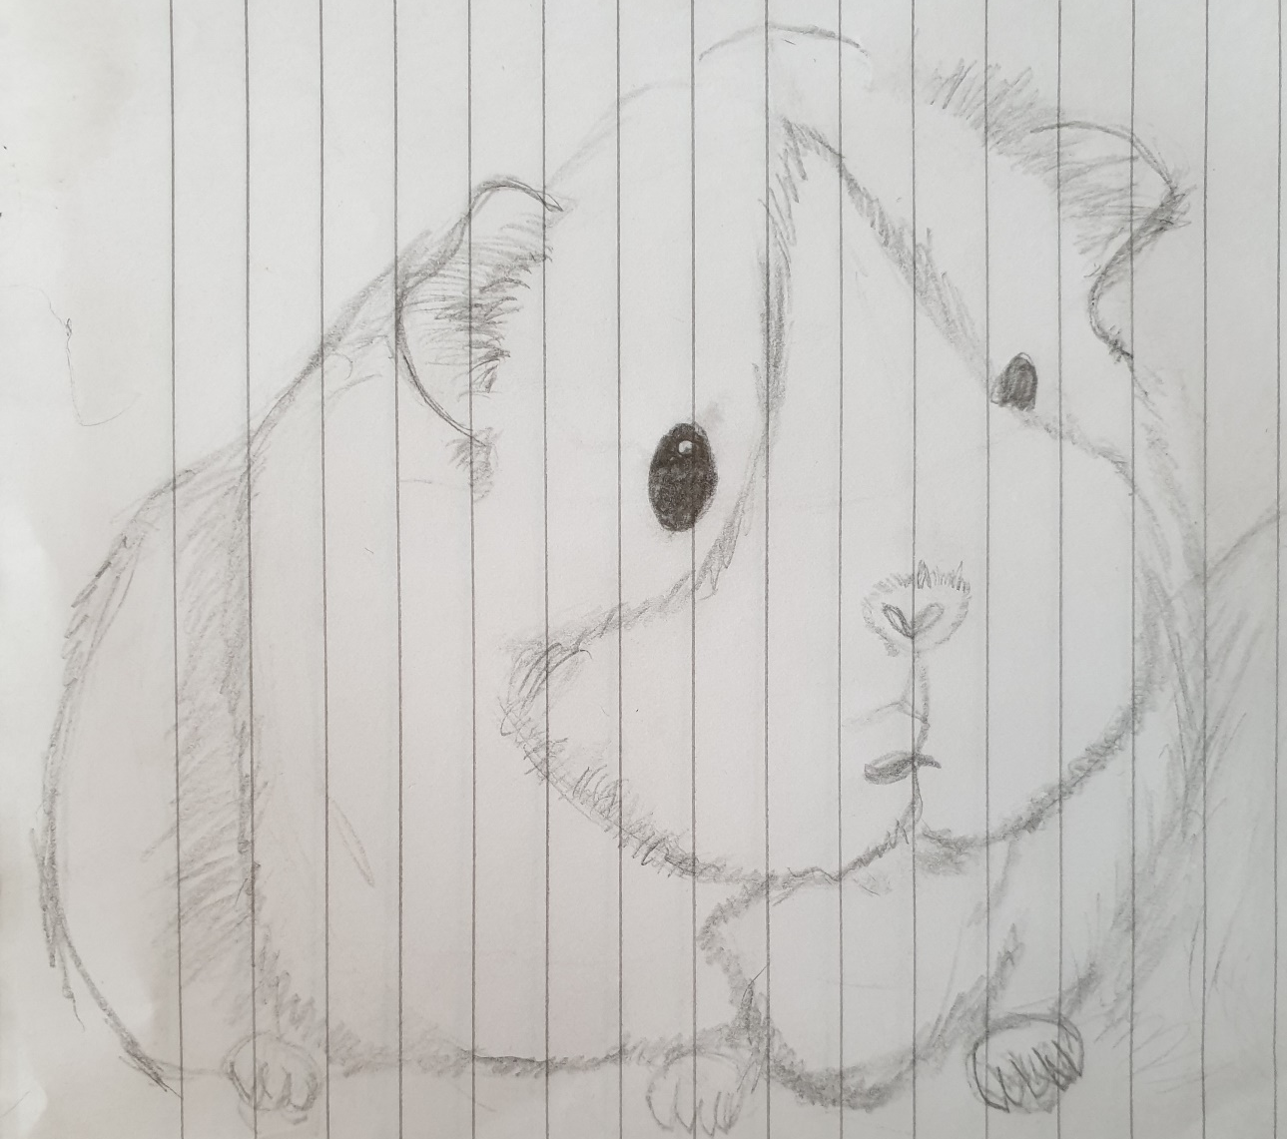
- Sense of smell: guinea pigs have extremely sensitive noses; they can smell things from up to a mile away!
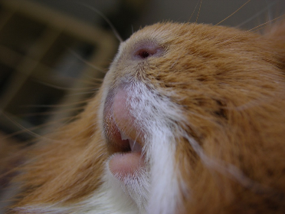
- Padding on their feet: My guinea pigs walk on soft padding but for a part of their cage we laid down wood shavings, these are not as softas the padding so they have pads on their feet to help cushion them.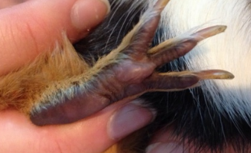

- Noises: Different sounds a guinea pig makes means a different thing, if a guinea pig makes a certain noise, they can communicate with another guinea pig. There are ways to understand what they are saying if you listen to the tone and volume.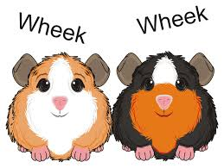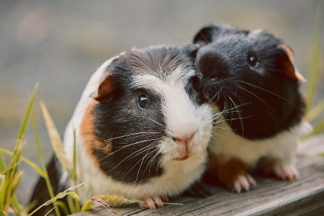

- Their eyes: Since guinea pigs are a prey animal, they always need to be looking behind their back. Guinea pigs have adapted to this by having eyes on the side of their heads to see in both directions.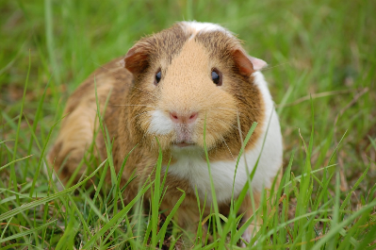

- Hearing: guinea pigs are very good a listening for even the slightest bit of noise, they would even hear if you dropped a needle. This is good because if something is coming their way, they have a lot of time to run and hide although normally a guinea pig would freeze and wait until danger has passed.

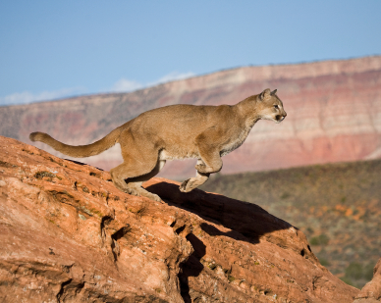HOW DO PUMAS ADAPT?

- Their fur is a light brown-dark yellow colour, perfect for the rocky habitat they live in.
- Their sense of smell really helps when sniffing out prey.
- Their hind legs are strong and big, great for jumping onto higher rocks.
- Hearing is vital when it comes down to food, they are able to hear where the prey is, then pounce.
- The pads on their paws are good at cushioning the sharp rocks on the floor.
- Their claws are used to grab onto the prey when hunting.
- Pumas are really good at chasing after their prey, an important skill when living in the wild.


