Tuesday 26th January
IALT demonstrate understanding of the scientific meaning of adaptation.

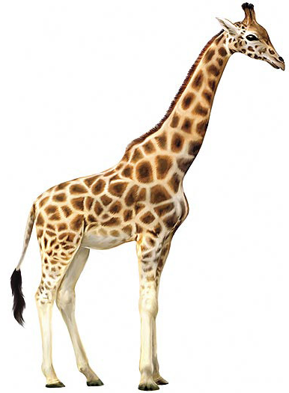 How do you think a giraffe has adapted to where it lives?

- It has a long neck to reach leaves in tall acacia trees
- It has a camouflaged coat with spots of different sixes to help it hide in the African savanna
- It has a long tough to help it get leaves off the trees
- It has a fringed tail to keep flies

Black Panther
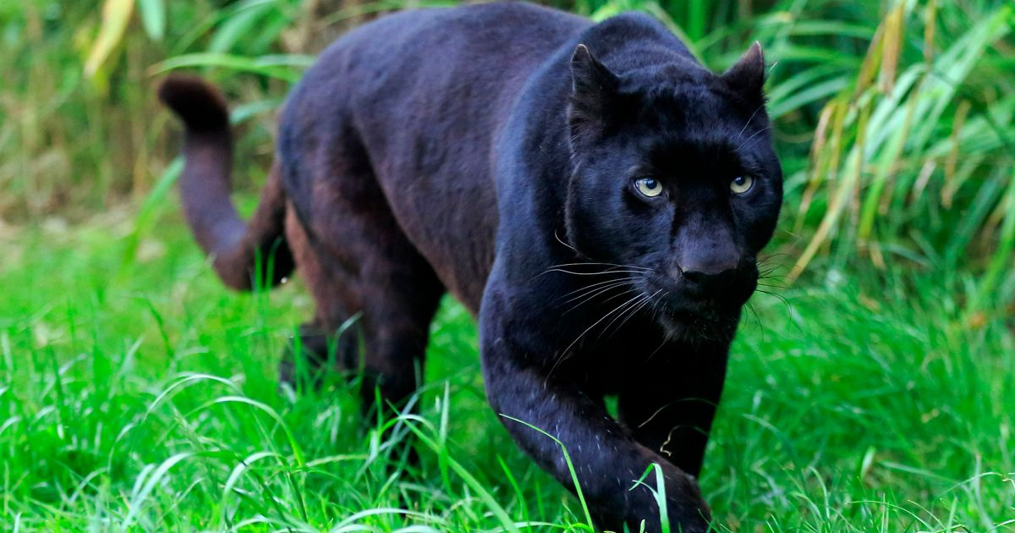

A black panther lives in dense rainforests. Their diet is mainly made out of Deer, Antelope, Gazelles, warthogs and other small to medium sized herbivores. The reason they live in rainforests is because it easy to hunt down, their prey, easy to find shelter and water and most importantly easy to breed. A gestation period for a panther is 3-4 months so in that moths they will take shelter and get ready. They also like to dive to relax themselves after been injured or severely hurt. Panthers are one of the top 5 on the food chain they are quick and get away and catch any prey easily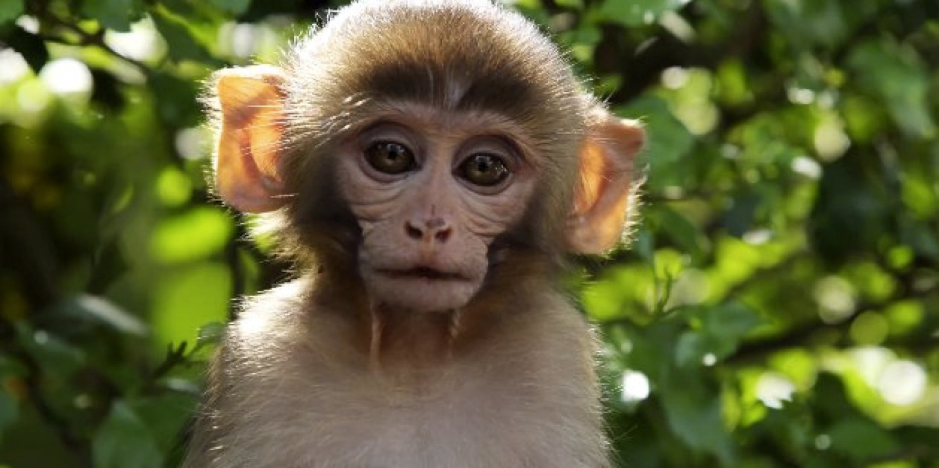

A monkey lives in the amazon rainforest due to its hot and very wet climatic conditions. Monkeys eat fruits, seeds, leaves, stems, scorpions and many more. When in love monkeys use grooming to strengthen and repair relationships Monkeys live between 10-50 years. Depending on the species the gestation period lasts between 137-241 days. It's very easy to find monkeys habitats as they mainly live-in trees.

