Sabre tooth Tiger

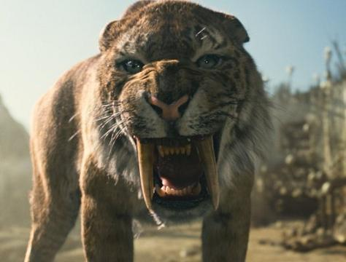

The Sabre tooth Tiger is a prehistoric carnivorous mammal. The Sabre tooth Tiger came extinct at the end of the Ice Age 10,000 years ago

Sabre tooth tiger is known for its pair of long canines that could grow up to 8 inches which were used it to inflict deep stabbing wounds. Its jaw was massive and could open over 120 degrees twice that of a modern big cat. He has a coat like a lion The Sabre toothed Tigers the same what is a lot stronger as a African lion or Tiger .the Sabre tooth Tiger was a carnivore and you still like to eat herbivores. We think the Sabre tooth Tiger came extinct because of climate change and lack of food .

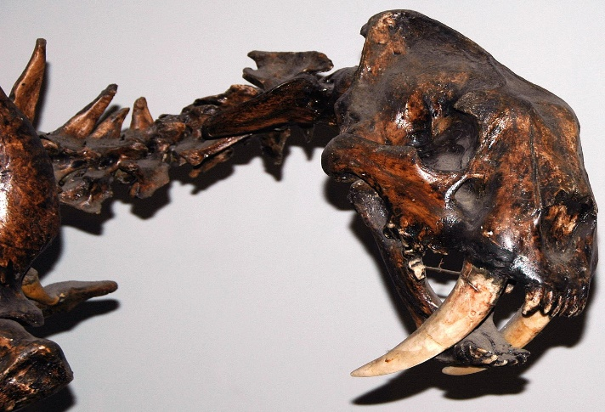 Sabre tooth fossils have been found in America about Woodlands areas and pine forest They lived in grassy Meadows and in flood Plains.
This Photo by Unknown Author is licensed under CC BY-SA

