Monday 1st February 2021
IALT: know the origin of some of the foods we know and love.
IALT: consider how diversity of culture, heritage and background bring positive opportunities and choices.
Foods of the world
Task:
Create a poster about a food from another country. Include images and website links to make it interesting and interactive.
PIZZA
By Iris Cahill

Pizza originates from Italy but is a beloved dish for many other countries!

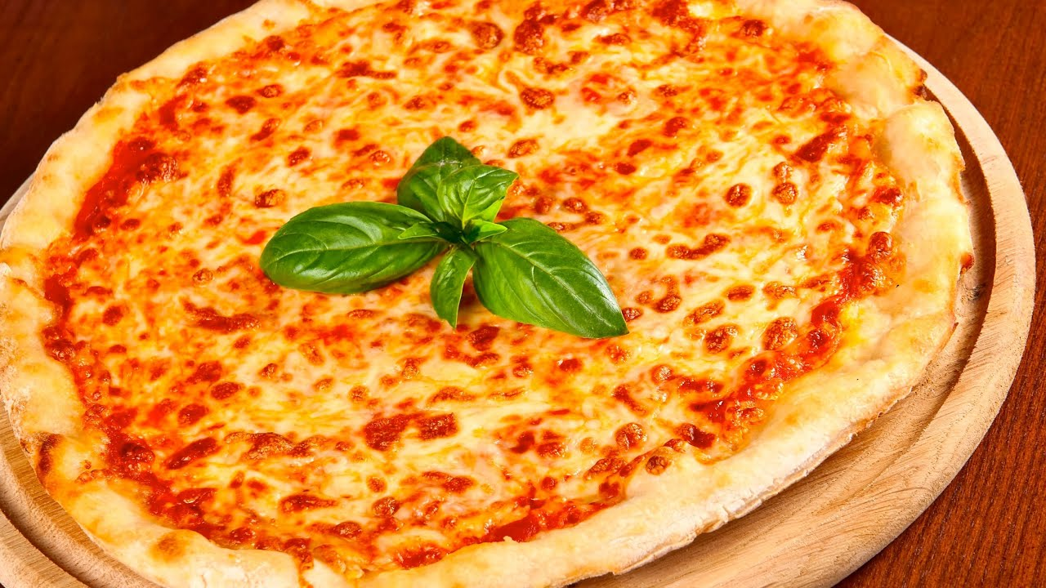

Here are some standard types of
pizza:
- The margherita pizza
- Peperoni pizza
- Pizza napolitana
- Calzone- a folded pizza
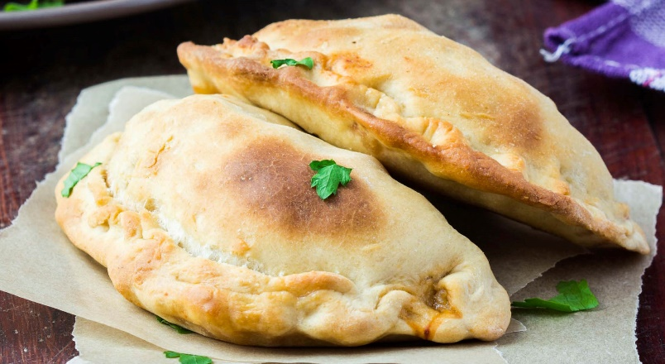
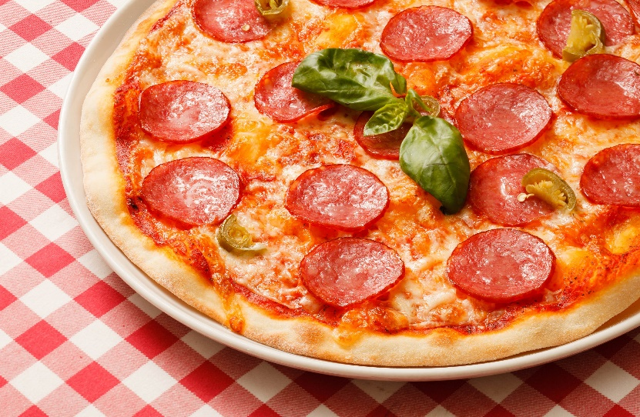
Here is a ‘Pizza margherita’ (a cheese pizza), yum!
Here is a peperoni pizza! Yummy!

