 | Facts about the Dodo
Latin Name:  (Raphus cucullatus), |  | Flightless bird from Mauritius

- Relative of the pigeon  - Weight: 23kg (50lb)  - Height: 3ft  - Colour: Blue-grey  - The Dodo has small useless wings  - Tuft of curly feathers at its rear end | 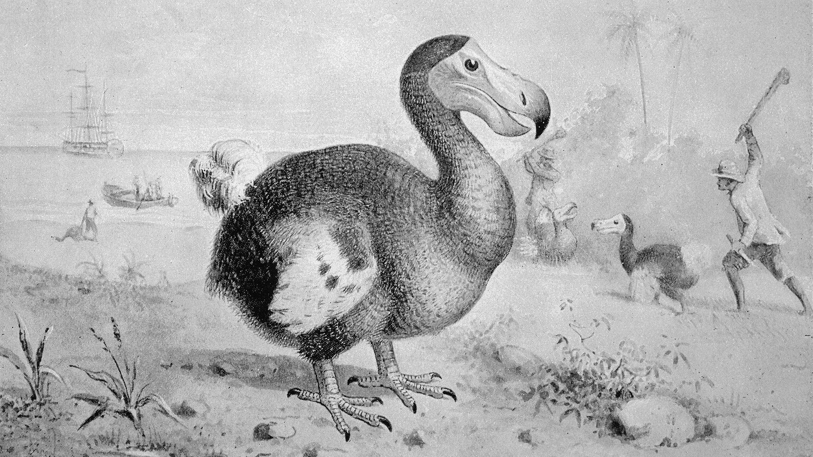 |  |  | - Became extinct in 1861  - The most well-known human induced extinction .  - Dutch sailors, arriving on the shores of Mauritius , hunted them to extinction.
- The Dodo’s head was 23cm (9 inches) and it had a blackish bill with a hooked tip |  | - The female Dodo only laid one egg at a time, unlike other birds that lay multiple eggs | - The Dodo is mentioned in the book ‘Alice’s adventures in Wonderland’
Diet:  The dodo ate fallen fruit, nuts, seeds, bulbs and roots. It is also believed to have eaten crabs and shellfish |  |  | Habitat:  Primarily a forest bird but would occasionally venture to the shoreline
- In 2016 scientists discussed the possibility of the Dodo’s resurrection (de-extinction).
The debate of the ethics of this and using de-extinction to alter natural history has stopped this from advancing any further.

