Italian Food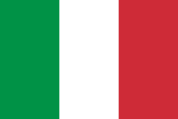
Italy, a European country with a long Mediterranean coastline, has left a powerful mark on Western culture and cuisine. Its capital, Rome, is home to the Vatican as well as landmark art and ancient ruins. Other major cities include Florence, with Renaissance masterpieces such as Michelangelo’s "David" and Brunelleschi's Duomo; Venice, the city of canals; and Milan, Italy’s fashion capital.
Italian cuisine is generally characterized by its simplicity, with many dishes having only two to four main ingredients. Italian cooks rely chiefly on the quality of the ingredients rather than on elaborate preparation. Ingredients and dishes vary by region.
Some of the most popular and delicious Italian dishes are:
Pizza. Pizza was born in Naples. Tomato sauce is added to the thin layer of dough, then cheese and topped with a variety of toppings, then cooked in a pizza oven.
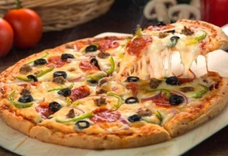
Italian recipes - BBC Good Foodwww.bbcgoodfood.com › Recipes › Collection
www.bbcgoodfood.com › Recipes › Collection

Italian recipes - BBC Good Food
www.bbcgoodfood.com › Recipes › Collection

Italian recipes - BBC Good Food
www.bbcgoodfood.com › Recipes › Collection

Baked lasagna.
It might surprise you to learn that lasagna didn't originate in Italy. Italy claims it was them, but they should only be credited for perfecting the layers and layers of the scrumptious dish that we call lasagna. It actually originated in Ancient Greece a very long time ago.
Authentic lasagna is made up of layers of meat sauce and pasta - there are no layers of cheese in between. Enjoy this true Italian classic as is or omit the meat for a vegetarian version.
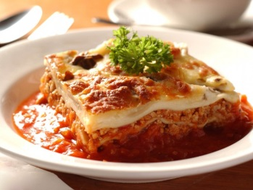

Spaghetti is the long/short round strands of pasta which are thinner than a match. Bolognese is the name given to a sauce used for pasta which uses ground beef and tomatoes as its main ingredients. It can also be referred to as “Ragu” which is exactly the same sauce.
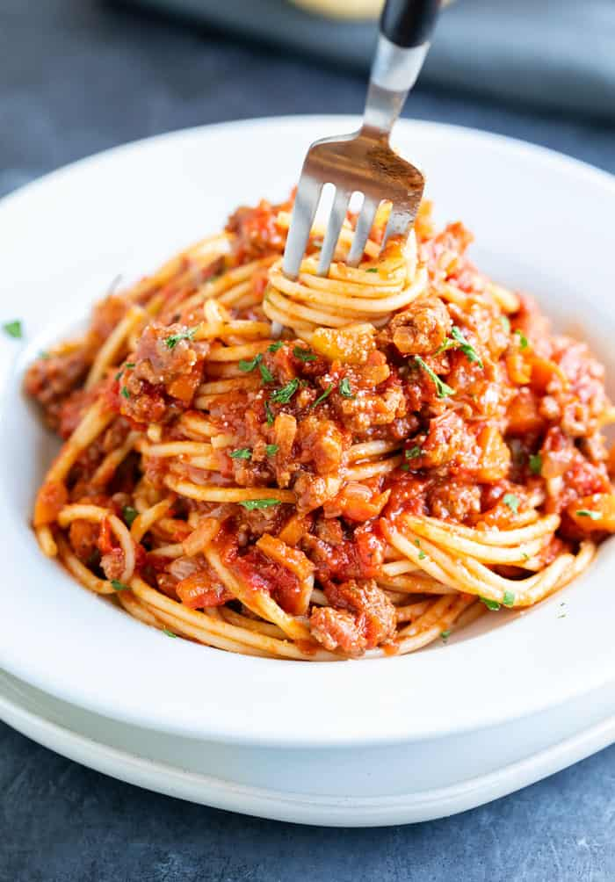
https://www.deliciousmagazine.co.uk/cuisine/italian-recipes/

Italian recipes - BBC Good Food
www.bbcgoodfood.com › Recipes › Collection

Italian recipes - BBC Good Food
www.bbcgoodfood.com › Recipes › Collection

