Sushi
Sushi is a traditional Japanese dish of prepared vinegared rice, usually with some sugar and salt, accompanying a variety of ingredients, such as seafood, often raw, and vegetables
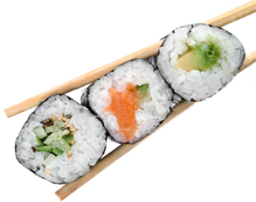 | Fact:  In japan, if the type of sushi is shown before the word sushi, the sushi word becomes “zushi” | 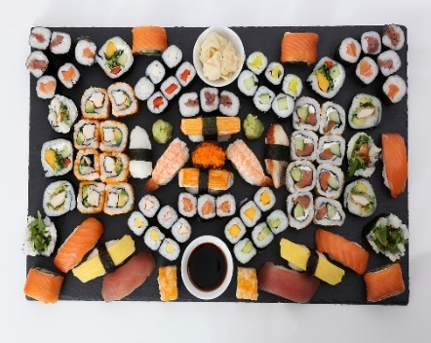 | Fact:  Sushi is usually presented very orientally, usually in decorative circles or patterns, as shown to the left.
Sushi recipes - BBC Good Food  This link leads to multiple sushi recipes. | 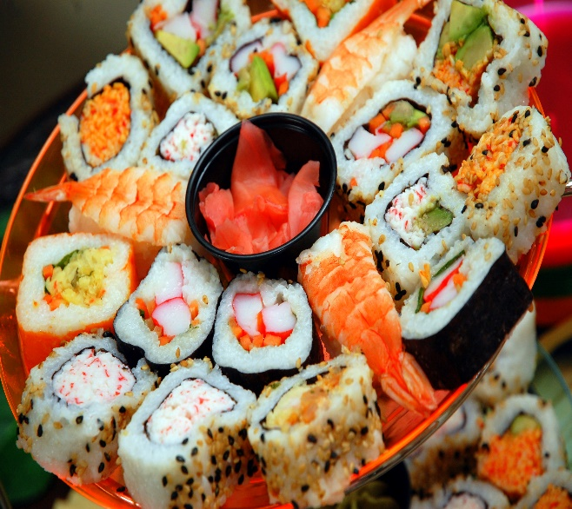 |  | 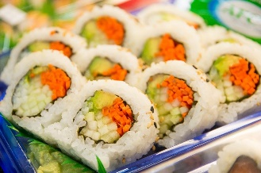
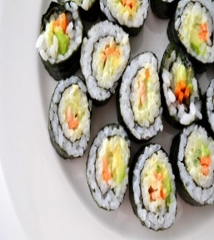  This Photo by Unknown Author is licensed under CC BY-NC |  |  | Fact:  Although the Japanese get all the credit for the sushi we have today, sushi didn’t actually originate in japan. It is thought to have started in southeast Asia.
Fact:  Sushi isn’t actually meant to be eaten with chopsticks, its meant to be eaten with your hand. | Simple sushi recipe - BBC Good Food <- This link will take you to a recipe for sushi. | 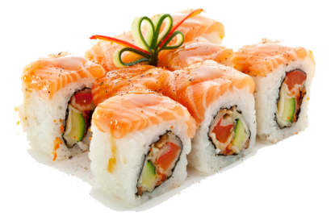  This Photo by Unknown Author is licensed under CC BY-NC | Fact:  At first, sushi was never eaten with rice, so sushi rice didn’t even exist back then!

