My World Food Recipe and cooking

Type or copy and paste your ‘World Food Recipe’ into this document.
Take photos as you cook. Copy and paste them here or add them as separate files to the assignment.
Have fun!

Ingredients
For the dough
650g/1lb 7oz ‘00’ flour (or strong white flour), plus extra for dusting
7g dried easy-blend yeast
2 tsp salt
25ml/1fl oz olive oil
50ml/2fl oz warm milk
325ml/11fl oz warm water
Method
To make the dough, mix the flour, yeast and salt together in a large bowl and stir in the olive oil and milk. Gradually add the water, mixing well to form a soft dough.

Turn the dough out on to a floured surface and knead for about 5 minutes, until smooth and elastic. Transfer to a clean bowl, cover with a damp teatowel and leave to rise for about 1½ hours, until doubled in size.

When the dough has risen, knock it back, then knead again until smooth, roll into a ball and set aside for 30 minutes to 1 hour until risen again.

Preheat the oven to its highest setting.

Divide the dough into six balls and roll each out on a lightly floured work surface until 20cm/8in in diameter. (You can also make one big pizza.) Spread a little passata (or homemade tomato sauce) over each pizza base and top with your favourite toppings.

Bake the pizzas in the oven for 10–12 minutes until the bases are crisp and golden brown around the edges and any cheese on top has melted.
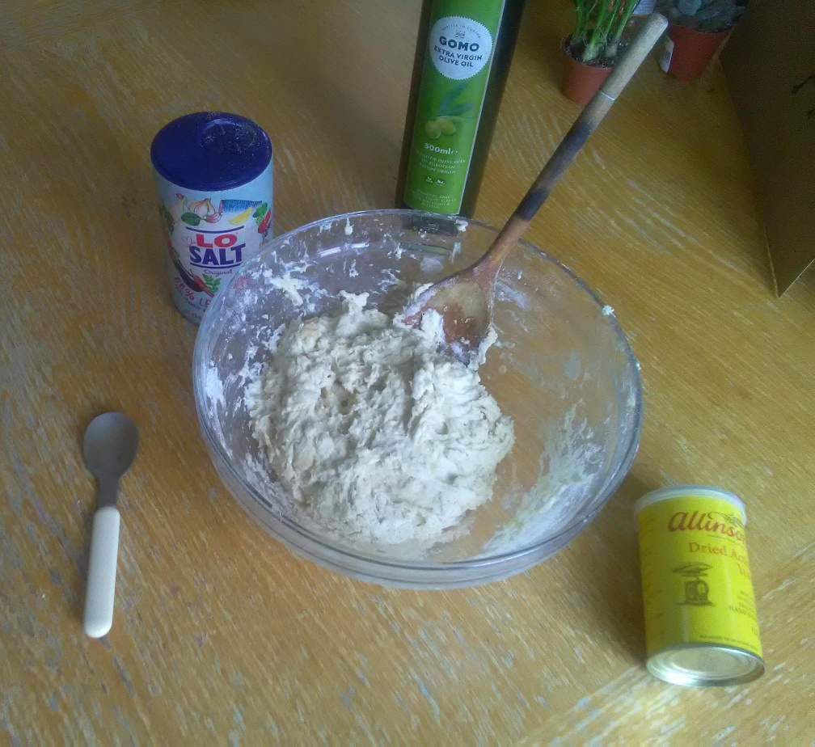
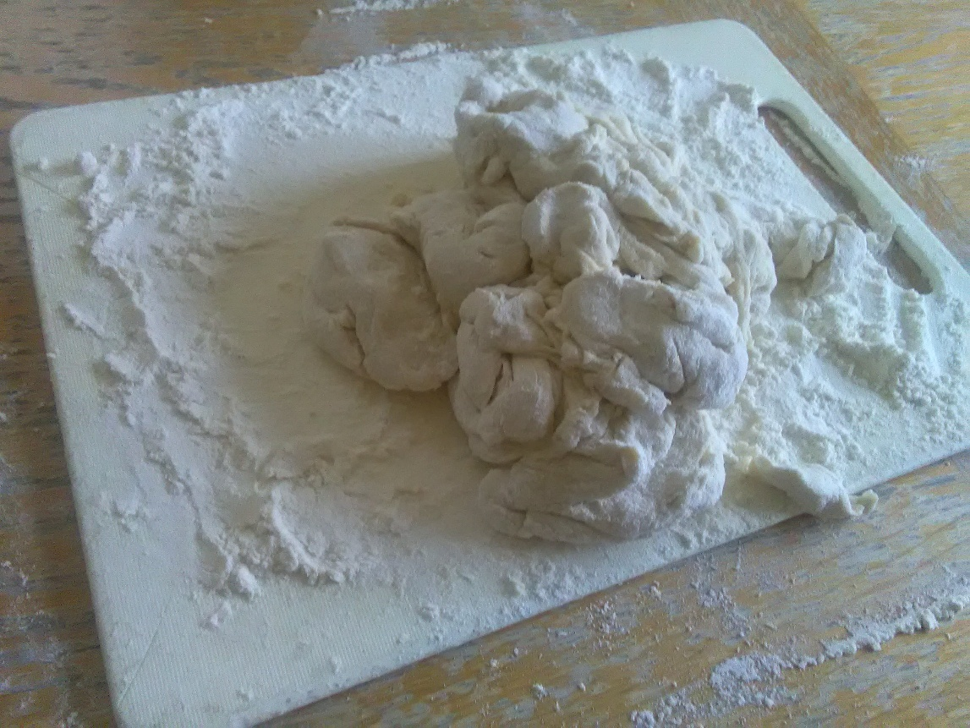
I made two pizza’s one with tuna and a veggie one.
Sauce

I cut up onions and garlic and let them boil in a pot on the stove at the lowest temperature. After I came one hour later to add the chopped tomatoes in and then we left it.


