My World Food Recipe and cooking Andy
(Hong Kong home style fried rice)
Fried rice ingredients:
- Rice 5. Garlic 9. A little bit of sugar
- Meat 6. Mixed vegetables 10. Pepper
- Shrimp 7. Onions 11. Soy sauce
- Shallot 8. A little bit oils
The practice of fried rice:
- First put some oil in the pan.
- Then put the garlic in the pan and mix it.
- And put the other ingredients such as meat, shrimp, shallot, mixed vegetables and onions in the pan and fried it.
- After the ingredients are cooked, then put the rice and soy sauce mix it and fried it together. But don’t forget put a little bit of sugar.
- Finally, if you want to make the fried rice more spice or you want to make your own style of fried rice, you can put more pepper or chili sauce or other ingredients.

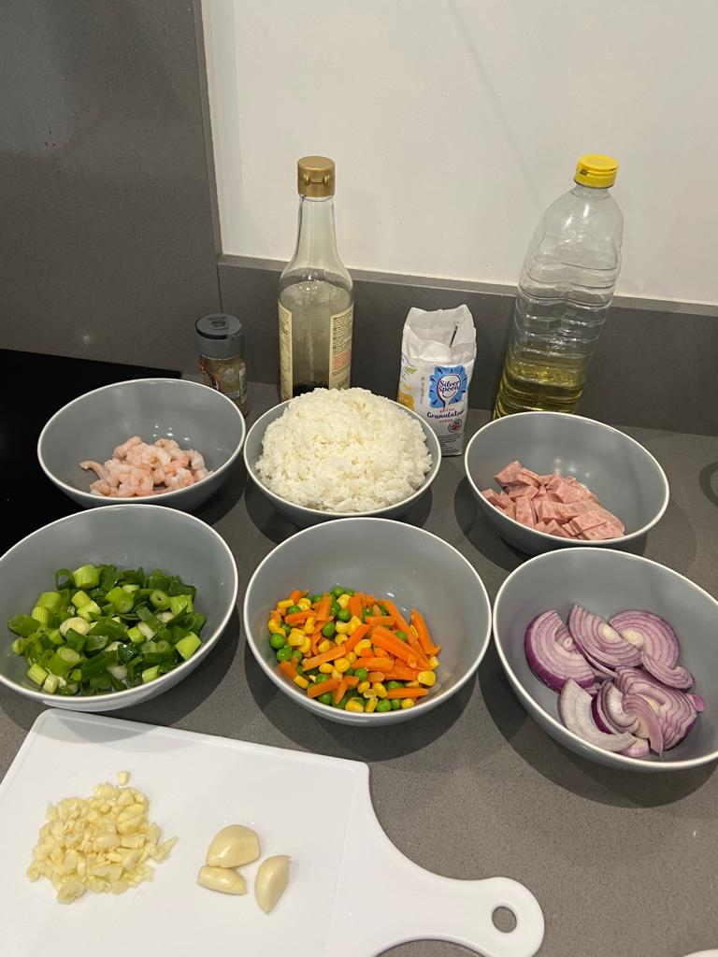
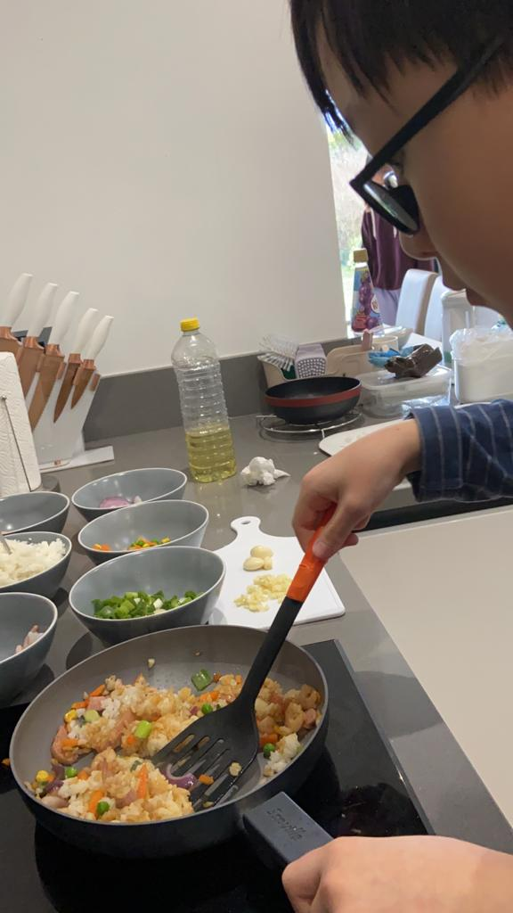
Photo:


