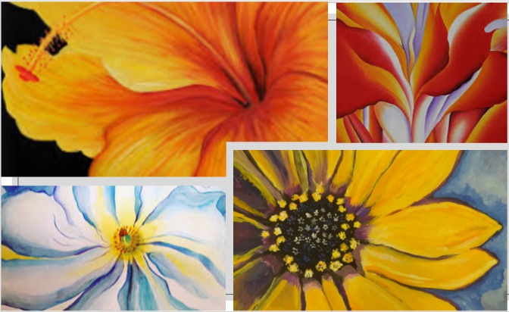
Tuesday 9th February 2021
IALT explore different textures in colour using a range of mediums.
IALT express feeling through artwork
Task:
Create your own flower artwork in the style of Georgia O’Keeffe!
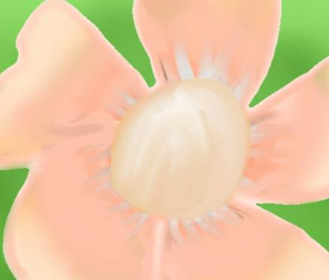
You can do one big picture of a flower or 4 smaller versions and put them next to each other using different mediums. Or do 2 or 3! Take a picture and send it to your teacher or attach it to your assignment. Within the assignment there are also pictures of different flowers that you can use for inspiration!

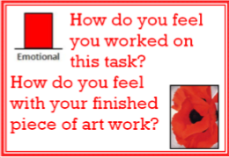
Evaluation:
I felt relaxed
Good about it and I did well

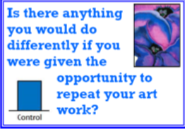
Fix the out line of the flower and changed the cloour

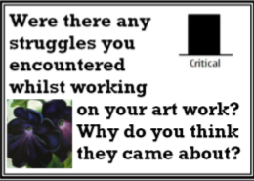
Yes the layering was all mixed up and so I had to fix it and it took a while
I’m not quite sure

