Tuesday 23rd February 2021
IALT: Write a story opening in different styles.

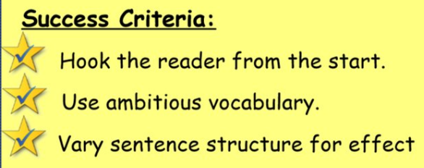

Task: Write a new opening for Kensuke’s Kingdom focusing on description.

Think about the path, flowers, front garden, the view, the weather, the town, the road etc.

Open the WAGOLL and use the sentence openers to help you!

It was a cold, rough night in late November, as the stars in the sky twinkled above. A bed of a frosty blanket lay, comfortably on the uneven, concrete tiles. The brightness of the winters atmosphere. As the ferocious wind, scarcely blew away everything in sight. Boot in-prints, carved deeply into the snow, that ran upon the street. The streets were as empty as a vase; listening to the silent murmurs being shared upon houses. Whistling a solemn tune, the birds flew sky-high, watching the very little people, that walk by.

