  Steve Reich was born in 1936. He music is known for its for his complex layering and fast interlocking patterns  https://youtu.be/xzeNll8EPh4 | MINIMALISM |   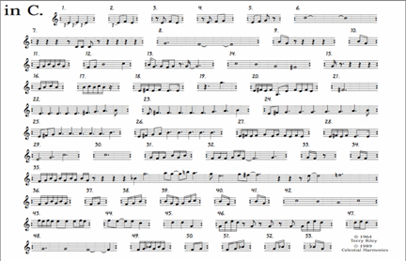  Terry Riley was influenced by jazz and Indian classical music, his music became notable for its innovative use of repetition, tape music techniques, and delay systems.
 | Minimalistic music started in the 1960’s . It originated from the West Coast of Africa
 | Interlocking repeated phrases and rhythms are used
 | Notes are played singularly rather than together giving broken chords
 | It can sometimes use features such as phase shifting (using different speeds)
 | Music has layers and when put together form a musical collage
 | Ambiguity of the tone, where the key is not clear and different harmonisations are possible
 | Layered textures of music
 | Interlocking repeated phrases and rhythms
 | Slow harmonic changes
 | Melodies emerge as the same notes occur at the same time in the phrase, giving them emphasis
The combined effect produces music that can be almost hypnotic.



