Tuesday 2nd March 2021
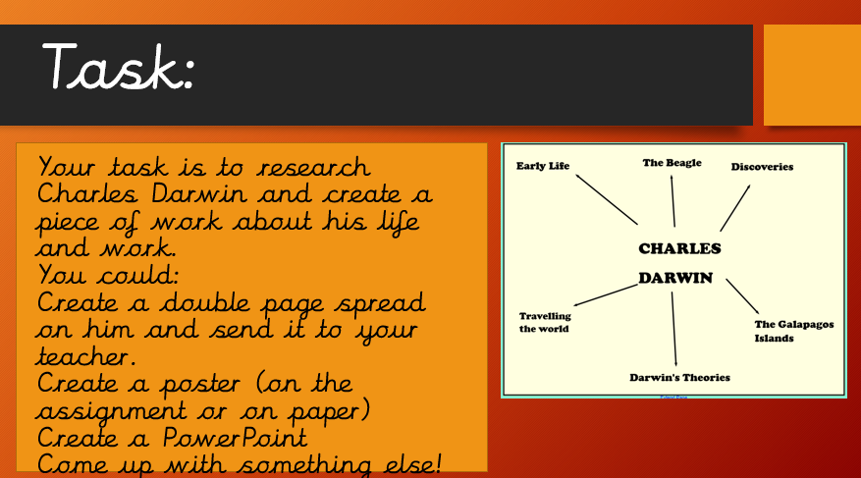
In History IAL about the life, work and discoveries of Charles Darwin.
Use the resources (PowerPoints and Research) within your assignment to help you with you task.
Charles Darwin intro:
He was born at the mount house in 1809, the 12th of Feb. His full name was Charles Robert Darwin. He died on 19th April 1882 meaning he lived 73 years. He was fascinated by the natural world from a young age. He also loved reading nature books and devoted his spare time to exploring the fields and woodlands around his home, collecting plants and insects.
THE SHIP “Beagle”
In 1831 Charles Darwin received an invitation to join the Beagle for a trip around the world. For most of the next five years, the Beagle left when they got to the coast of South America, leaving Darwin free to explore the continent and islands the most famous place he visited; the Galápagos.

ALFRED WALLACE
Many people think that Alferd and Charles worked together from the start. But no- this is not the case. Alfred’s full name was Alferd Russel Wallace who was born the 8 January 1823 and died the 7 November 1913 he was a British naturalist, explorer, geographer, anthropologist, biologist and illustrator. He is best known for, by his self, conceiving the theory of evolution.

