Upton Junior School Homework
Set Friday 11th March
Due Wednesday 16th March
Inspiration Women!
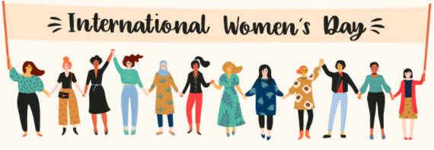
In celebration of this year’s International Women’s Day 2022, your teachers would like YOU to research an inspirational woman who has made an impact on the world. This could be a woman in science, art, music, technology, sport or fighting equality; it is completely up to you!
You can present your work in any format: through art, poetry, posters, writing or using technology. We are going to display those that make us go WOW in the hall!
Miss Reed’s inspiration is Malala Yousafzai: a Pakistani protestor for equality in education and Miss Scarr’s one of many is Emmaline Pankhurst who fought for the right for women to vote!
Examples:
- Art: Freida Kahlo
- Science: Marie Curie
- Racial Equality: Rosa Parks
- Sport: Nicola Adams (Boxer)
Helpful sites:
https://www.internationalwomensday.com/
https://www.natgeokids.com/uk/discover/history/general-history/international-womens-day/
https://www.science-sparks.com/wonderful-women-in-stem/

