Children can choose a piece of homework they would like to focus on each week. They do not have to do ALL of the tasks, just ONE PER WEEK. They can choose to record in their book, send in photos or bring the homework in to show.
Research the Ancient Islamic Civilisation House of Wisdom. Present your findings in an information sheet. | Write a set of instructions on how to build an electrical circuit. | Make a diary of all the times you use electricity in your day. | Invent your own electrical item that has not yet been invented! Use pictures and labels. | Draw a picture of all the mains and battery appliances you can find in your home and label them.
Is it possible to live without electricity? Agree or disagree. Explain your answer. | What did the early Islamic civilisation invent? Choose one and create a poster of your findings. | Make a double page spread to represent life in an Ancient Islamic Civilisation. | Play this online electrical safety game https://www.switchedonkids.org.uk  /electricalsafety-in-your-home | Research art from the Ancient Islamic Civilisation. Present your findings how you would like to.
Create a geometric pattern. | 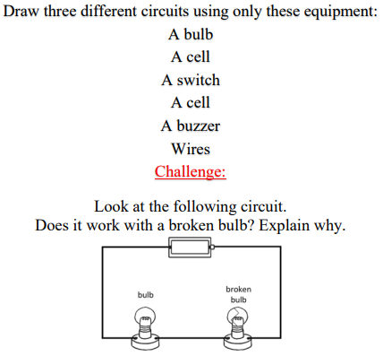 | Draw a map of the Silk Road and label trades that would have used it. | 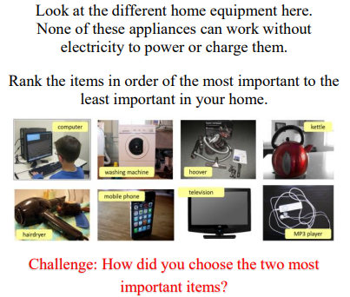 | Build a model of the city of Baghdad during the Golden Age of Islam.

