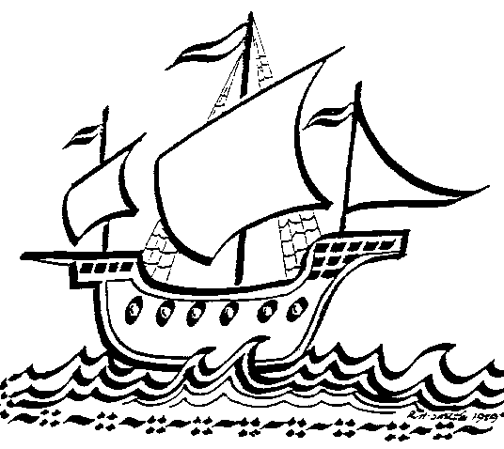
Upton Junior School

Term 5 Art Competition: Laurel Burch
- The competition this term will be to draw an animal in the style of American Artist Lauren Birch.
- Your art piece can be ANY size.
- Hand your entries into the Art Room by Friday 17th May with your name and class clearly labelled.
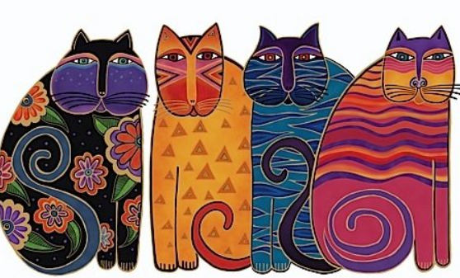
- There will be 1 winner from each year group. All entries will receive a small prize.
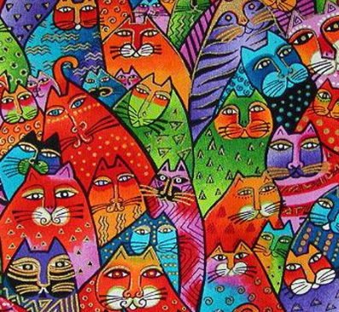

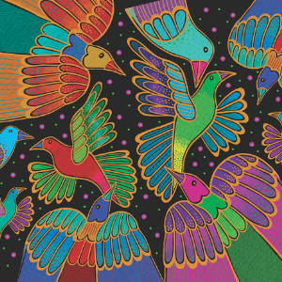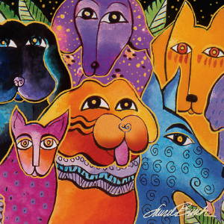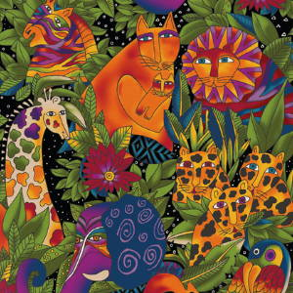
I look forward to seeing your wonderful creations! Miss Reed

