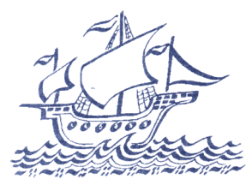 | UPTON JUNIOR SCHOOL  Executive Headteacher: Mrs M Lewis  Heads of School: Miss D Arthur (Lower School) & Mr D Walker (Upper School)  01843 861393  Part of The Viking Academy Trust

Kingswood Suggested Packing List
All children must wear their Upton sweatshirt/fleece to school for the journey to and from Grosvenor Hall. If your child does not have one, they can be obtained via 'lost property'.
Please clearly label or mark each item with your child's name
- waterproof coat
- Carrier bags (for dirty clothing)
- 2 pairs of outdoor shoes (lace up or velcro). Please no wellington boots
- 1 pair of slippers or plimsolls to be worn indoors
- enough underclothes
- jeans or tracksuit bottoms (children must have long trousers for some activities)
- shorts
- t shirts - these make a good base layer if the weather is chilly!!
- tops and sweatshirts – hopefully we won’t need them! (children must have long trousers for some activities)
- pyjamas/night clothes
- soap, flannel, roll-on deodorant, toothbrush, toothpaste, towel (no aerosol please)
- up to £5 spending money
- Lip balm, suntan lotion
- water bottle (this can be refilled during the course of the trip)
Skirts are not appropriate. 'Best clothes' are best left at home!
Every item, down to underwear and socks must be labelled.
Jewellery, even earrings are best left at home. If they cannot be removed, only studs should be worn. Hair must be tied back away from the face for all activities.

