
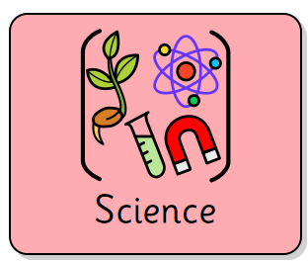
In this unit, in Science, the children will learn how humans and some other animals have skeletons and muscles that support, protect and help it to move. They will also investigate nutrition and how animals, including humans, need the right type and amount of nutrition from food. In Design Technology, the children will learn about food technology.
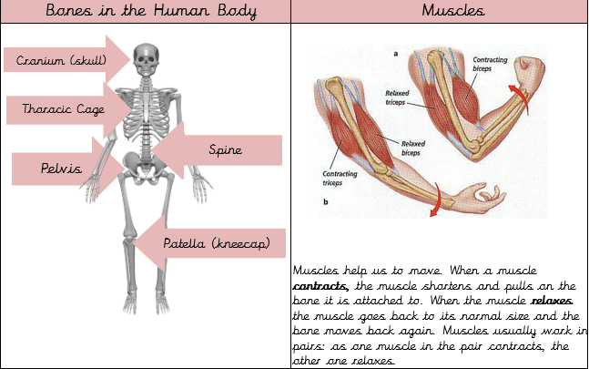
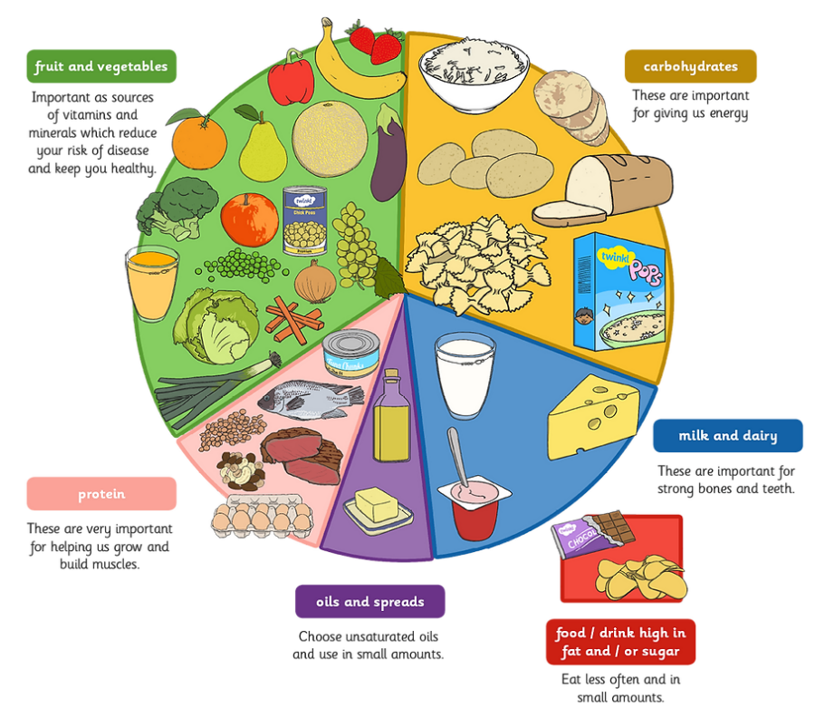
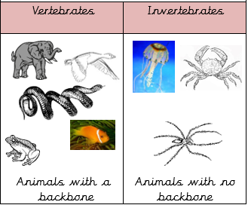
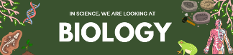



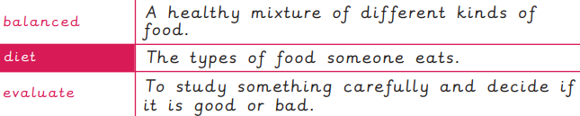
Skills


